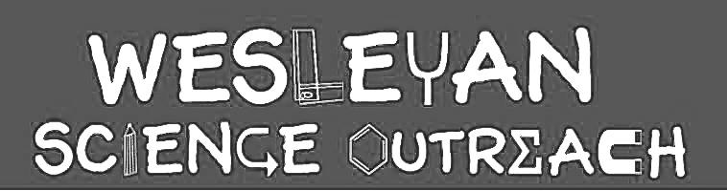

Flower Anatomy and Pollination

This lesson focuses the different parts of a flower, and their roles in plant reproduction. Students will also learn how pollination works, and its importance for all life on Earth. We will explore mutualistic relationships between specific pollinators and flowers.

Material List
Key Words

- Pistil
- Stigma, style, ovary
- Stamen
- Anther, filament
- Pollen
- Pollination
- Pollinator
- Mutualism

- Printed field journal template (or notebook/paper)
- Writing utensil (optional: colored pencils/crayons, markers)
- Stapler
- Time to go outside and make observations
- Optional: flower, tape, tweezers, magnifying glass or microscope

Activities

1. Flower Anatomy/Dissection Video
Duration: [7 minutes]

Video: https://youtu.be/fRRXX8aYo18

The purpose of a flower is to help the plant reproduce (create more plants) by producing seeds. When we look at flowers, we typically notice the colorful petals, but if we look closely, there are many important parts of the flower hidden inside! A flower dissection video is included.

Parts of a flower:
- Pistil: The pistil is the female part of the flower; it is made up of the…
  - The stigma is a sticky end near the top of the flower that collects pollen from other flowers.
  - The style holds up the stigma, so it is easily accessible and prevents contamination of the pollen. It also allows pollen to travel from the stigma to the ovary.
  - The ovary contains ovules (similar to eggs) which develop into seeds once they are fertilized by pollen.
    - Ovules: develop into seeds
- Stamen: The stamen is the male part of the flower, and is made up of the…
  - The anther is a pouch-like part that creates and stores the flower’s pollen.
  - The filament is a long, hair-like stalk that holds up the anther.
- Nectary: The nectary produces sugary nectar which attracts pollinators.

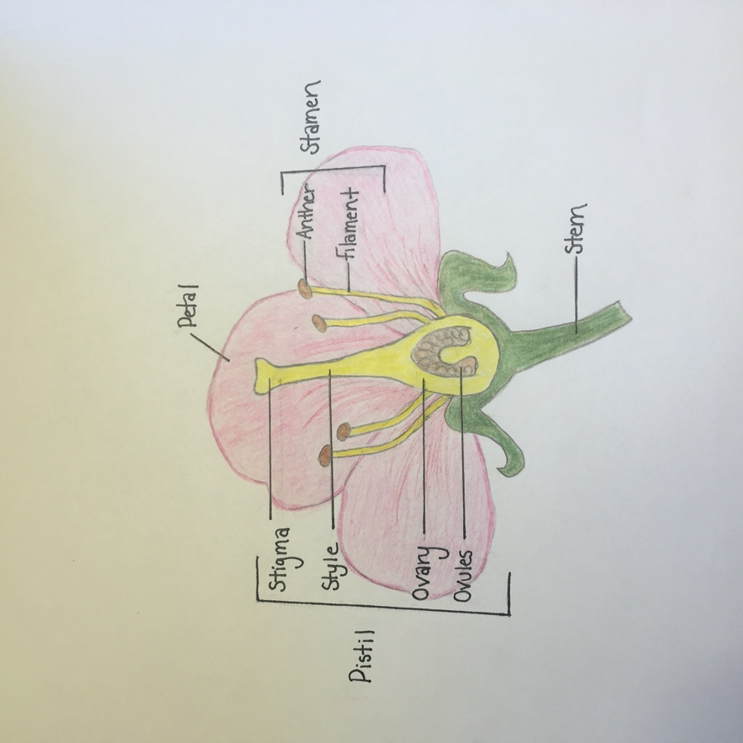

Note: flowers either have male parts, female parts, or both. If they have both, they usually must still receive pollen from other flowers to create seeds, although some can fertilize themselves.

2. Pollination/Mutualism PowerPoint
Duration: [5 minutes]

Video: https://youtu.be/YgWRbkT-w7o

Pollination:
The animals that pollinate flowers are called pollinators! Most pollinators are insects, such as bees, butterflies, moths, or flies, but birds and bats can also do the job!
Pollinators are attracted to flowers to find food (nectar), and when they land on a flower, pollen gets stuck on their bodies and/or legs. When they visit the next flower, the pollen brushes off and sticks to the stigma of the other flower, this is pollination!

Steps of Pollination:
  - Pollen is produced and released from the anther of the flower.
  - Pollen is moved to another flower by pollinators (or sometimes the wind).
  - Pollination occurs when the pollen lands on the stigma of the new flower.
  - Pollen travels down the style to the ovary and fertilizes the ovules, which then become seeds.
Why is pollination important?
  - Many plants require pollination to make seeds to create new plants.
  - Animals (including humans) depend on plants for food and breathable air! Photosynthesis is important for oxygenating our atmosphere, and plants also sequester (take in) carbon dioxide from the air.
  - We could not survive without plants, and since plants rely on pollinators to transfer pollen so they can reproduce, it is important for us to help protect pollinators!

Mutualism: Mutualism is a type of long-term interaction between species where both species benefit from the relationship. Flowering plants and their pollinators have become adapted to one another over time for maximum mutual benefit, an example of mutualism! Because of the relationship, flowers get pollinated so they can reproduce, and the pollinators get food.

Pollinator preferences: Certain pollinators are attracted to specific qualities in flowers such as smell, color, and shape.

Note: Many common spring bulb flowers, such as daffodils and tulips do not attract many pollinators (since they have been genetically modified) but they are great to look at to understand the parts of a flower!

- Bee Preferences:
  - Most bee-pollinated flowers are yellow, blue, white, light purple
  - The scent of a flower is also important for bees. When a worker bee returns to the hive, the scent of the flower clings to its body, and the other worker bees detect this scent and seek out the same flowers.
  - Examples of bee pollinated flowers:
    - Fruit trees: apple, cherry, peaches, plums, and raspberry, blueberry, and black berry bushes, lilacs, sunflowers, daisies, dandelions, clovers, crocuses
- Butterfly Preferences:
  - Most butterfly pollinated flowers are bright colors such as red or orange or purple since butterflies are sensitive to these colors.
  - Butterflies do not have a well-develop sense of smell, so the flowers they pollinate are not strongly scented.
  - Butterflies have a longer proboscis (straw-like mouth part used to suck nectar) than bees, so the flowers they pollinate often have nectar hidden at the base of long spurs or fused petals which may look like trumpets or funnels.
  - Examples of butterfly pollinated flowers:
    - Lilies, goldenrod, milkweed, trumpet vine, columbine, aster, purple loosestrife
- Moth Preferences:
  - Moth-pollinated flowers are usually white or very light colored and open at night since moths are mainly nocturnal (awake at night).
  - Moths are very sensitive to smell, so these flowers have strong scents that attract moths even in the dark.
  - Examples of moth pollinated flowers:
    - Morning glory, honey suckle, bindweed, gardenia, evening primrose

Note: Example flower photos are included in the pollination PowerPoint video. .

3. Field Journal
Duration: [5-15 minutes]
Video Duration: [3 minutes]

Video: https://youtu.be/NSnl3TvUiDs

In this activity, students have the opportunity to make observations in a field journal like scientists! The goal of this activity is to integrate the information learned in this lesson and apply it to the real world in a fun and creative way! A video explaining this activity is included.

Steps:
- Print the attached field journal templates (or create your own using a notebook/journal).
  - Print double sided with short edge binding (find under ‘layout’) and fold pages to create a book
  - Print as many copies as you’d like: 1 copy = 4 observation pages (1 piece of paper), 2 copies = 8 observation pages (2 pieces of paper), etc.
  - Create a cover for your field journal if you’d like!
- Go outside (in your yard, a walk around your neighborhood, a hike, whatever works for your family) and observe the flowers you see.
- Record your observations!
- Observations to include:
  - Record the shape, color, size, and smell of the flowers, and try to be as detailed as possible!
  - Find and identify different parts of a flower, and create a labeled diagram/drawing including the different parts
  - Make and record a hypothesis to answer this question:
    - What kind of pollinator do you think pollinates the flower? (think about the color, smell, and shape)
      - Note: This is just to get students thinking about what they’ve learned about the preferred flower characteristics of different pollinators, not about concrete right/wrong answers! Most pollinators pollinate a wide variety of flowers!
  - Any other interesting observations!
    - Do you see (or hear) any pollinators nearby?
- Repeat this process with as many flowers as you would like! If you enjoy this activity, you could create a flower field journal to fill with observations of new flowers over the next couple months!

4. Optional Addition – Flower Dissection:
Duration: [5-10 minutes]

We don’t want to encourage students to pick a bunch of flowers, but if there is a flower on the ground, or one in your own yard that it would be okay to pick, students could perform a flower dissection. (See dissection video for details).

Steps:
  - Gently pull apart the flower (remove petals, use tweezers to separate parts if needed).
  - Identify different parts: stigma, style, ovary, anthers, filaments, etc.
    - Note: not all flowers will have every part.
  - Place parts on printed template, or tape individual parts into field journal and label them.
  - Make and record observations!
    - What color is the pollen? What does it feel like?
    - Is the stigma sticky?
    - Can you find any ovules in the ovary?

Conclusion
There is more to flowers than what meets the eye, and each part plays an important role in plant reproduction! Pollination is the process of transferring pollen from one flower to another and is carried out by pollinators. When flowers are pollinated, they produce seeds that allow the plant to reproduce. The relationships between flowers and their pollinators are mutualistic because both species benefit from the interaction.

