Emily Aoki
Sept. 24, 2019

Trees Are Very Cool!

Today we will learn about the world of trees and then play some fun games called Forest Doctor and Simon Says (Tree Version). This lesson plan explores different types of trees, different forms they take on as they grow, and why they are so important to planet Earth and its inhabitants.

Material List
Key Words

- Deciduous
- Evergreen
- Needle-leafed
- Broad-leafed
- Photosynthesis
- Oxygen
- Fruit
- Sap

- 4 tree bark specimens
- 4 leaves
- 2 broad-leafed
- 2 needle-leafed
- 4 root/full plant specimens
- 4 pictures of trees/leaves (deciduous, evergreen, broad leaves, needle leaves)
- 7 Evergreen vs. Deciduous trivia pictures
- 4 Simon Says pose pictures
- 80 tree structure coloring pages
- Crayons/markers

Activities

- Introduction – Structure of trees
Duration: [5 min]
*Italicized: script for club leaders and/or volunteers

Who knows what a tree is? Can anyone describe what a tree is for me?
Call on the kids for different descriptions of trees.

Pass out the coloring pages, crayons, and markers. Point out the different parts on the tree. Explain that a tree’s life starts as a little seed, which then sprouts a few roots and a little leaf, and eventually grows up into a full tree with lots of roots, a big, sturdy trunk, long branches, and thousands of leaves.

Then, after all the leaves are grown in and the tree is fully grown up, it will produce flowers, and then fruit or seeds (or both), which then drop to the ground and become their own, new trees.

Pass around the specimens of the tree bark and roots. Tree bark is the hard shell, or “skin” of the tree that protects the soft inside with the sap and nutrients. It keeps rain and water from getting inside. The roots spread out widely in all directions in the ground and help stabilize the tall tree just like the toes on your feet. There’s sometimes one root that goes straight down the middle and is longer than the rest – this is called the taproot, and it also helps keep the tree really stable and tall.

Re-collect the specimen. Ask if anyone has questions.

Now that we know a bit about how trees grow, what are trees good for?
Call on the kids again. Likely responses: climbing, chopping for firewood, treehouses, maybe paper, building things, making fruit…etc.

Is there only one type of tree? A tree is a tree is a tree? Or do trees differ?
Call on kids again. Ask them to detail some of the ways in which trees differ. (ex. Height? Leaf shape/color? Branches?)

Exactly. There are many different types of trees. They even differ depending on where you live in the world. Right? Where do pine trees grow? Where do palm trees grow? Where do bamboo trees grow?

Today, we’re going to learn about different kinds of trees and why they are valuable to people and the Earth.

- Sorting/Trivia – Types of trees
Duration: [10 min]

Pine, palm, and bamboo trees are all different species of trees. Can anyone tell me what a specie is?
They may or may not know what a species is. Ask them if they know about different dog and/or cat breeds and compare it to that.

Explain to the kids how, just like dogs and cats, who can have short hair or long hair, or be big or small, trees can have different features. Some have big leaves, some have small leaves, or leaves that look like needles (just like a Christmas tree). These characteristics are how people categorize trees into different groups, or species.

One way people sort trees is with the shape of their leaves. Pass around the broad and needle leaf specimens. Show the kids the picture comparing broad leaves and needle leaves. Ask them to identify the ways in which they are similar or different. Connect the features of the leaves to their names. Re-collect the leaf specimens.

Another way people sort trees is by the way they grow and live. Show the kids the picture comparing deciduous trees and evergreens. Who has heard of seasons? What are your favorite seasons? Let the kids call out their favorite seasons. Ask why those seasons are their favorite. Hopefully someone mentions fall.

Have you ever raked up fallen leaves into a pile? Or stepped on them as you walk because they’re crunchy? Those leaves come from deciduous trees. Deciduous trees drop their leaves in the fall and “hibernate” during the winter. Then when spring comes around again, they grow new leaves and/or flowers and fruit. Some examples of deciduous trees are maple and birch.

Show the kids the picture comparing deciduous and evergreen trees.

Evergreen trees, on the other hand, keep their leaves throughout winter. That’s why they’re called “evergreen” – because they’re ever-green. Some examples of evergreen trees are pine and fir.

Play trivia with the “Evergreen or Deciduous” print-outs. Answer key:
- Blue spruce – Evergreen
- Sugar maple – Deciduous
- Bamboo – Evergreen
- Oak – Deciduous
- Fir – Evergreen
- Palm trees – Evergreen
- Poplar tree – Deciduous

- Forest Doctor Game - What are trees good for?
Duration: [10 min]

There are many reasons why trees are important to the world. Can anyone name any?
See what the kids have to say. Here are some reasons why trees are great:
Food
Trees make us food!
- Fruit trees… Can anyone name any fruits that grow on trees?
  - Ex. apples, oranges, pears, grapefruits, lemons, persimmons, etc.
- Maple syrup comes from the sap that flows through the trunk of maple trees

Ask if anyone has ever tried maple syrup candies. They are made from the sap of maple trees. Sap is sort of like the “blood” of trees, which carries all the nutrients to the branches and leaves just like the blood in your veins carries oxygen to your arms, legs, and fingers. Sap is made from water that is collected through the roots, and sugar that the plant makes from photosynthesizing “aka living and breathing”.

Earth’s Ecosystem
On a related note, aside from sugar, trees also produce oxygen when they photosynthesize, AKA the plant version of “living and breathing.” That makes them great for purifying the air we breathe and giving us fresh oxygen.

Their roots are also very strong and form complex nets in the ground (feel free to bring out the root specimen again), which helps hold soil together, just like if you grabbed a handful of dirt, imagining your fingers as roots. This really helps when it rains a lot, because the dirt won’t erode away (AKA wash away).

They also provide shelter for animals… What are some animals that make their homes in trees?
- Ex. squirrels, birds, bugs, bats, bees, etc.

Do humans also make homes in trees?
- Sometimes! We make tree houses…
- But also, we use wood to build our homes, furniture, make paper, fuel our campfires…etc.

And of course, they provide us a lovely spot of shade on hot, sunny days.

Now the kids will play a game called Forest Doctor.

Many trees have medicinal properties. Today we are going to pretend that we live in the forest, and half of us are happy forest citizens that were recently struck with various illnesses. The other half will play the forest doctors, who will help our poor forest citizens by recommending them natural treatments, derived from trees, for their patients’ symptoms. Then we will switch roles, so everyone will have a chance to be a patient and a doctor.
Pair up the kids. Explain that first, the “patient” will tell their doctor what symptoms they have been experiencing, which they can read on the cards. The doctor will listen carefully and then read through the “treatment options” on their card, and recommend whichever one sounds like it will help.

Briefly breeze through the “treatment options” listed:
- Gingko Trees
  - Have beautiful fan-shaped leaves, which some people dry and then take as medicine to help their memory, concentration, and blood flow. A long time ago (~2600 BCE), people used to use it to treat asthma and bronchitis as well.
  - However, as with all things, moderation is key, and only a small amount of gingko is needed to have an effect, as too much can make it too powerful and will lead to serious side effects.
- Tea tree oil
  - Distilled from the leaves of the Melaleuca alternifolia (Tea Tree) plant, native to Australia.
  - The oil has anti-bacterial, anti-inflammatory, antiviral and antifungal properties. People often use it to treat acne, athlete’s foot, dermatitis or head lice (many skin conditions)
  - Contrary to the name (“tea”) which sounds like it’s edible, tea tree oil should never be swallowed! It should be used directly on the skin.
- Birch
  - Some people take supplements with extracts from birch tree leaves, which contain lots of vitamin C.
  - Birch can be useful for kidney or bladder infections, as it is a diuretic, which means it flushes out your urinary system.
- Bay Trees
  - Bay tree leaves, which have a very distinctive scent from the oil on the leaves, can be rubbed on your skin to ward off biting mosquitoes.

Hand out the cards accordingly. Once they are done, they can bring the cards back to you or a volunteer and swap roles (make sure to give the new “patient” a different set of symptoms than the first “patient”).

- Simon Says – Types of trees
Duration: [15 min]

Ask the kids if they have ever played Simon Says. If anyone has, you can ask them to explain the rules. Tell the kids that today we’re playing the “Tree Version” of Simon Says.

The rules to Simon Says:
- Have all the kids stand up and spread out amongst each other (at least an arm’s distance in all directions around each kid)
- A volunteer or club leader will act as “Simon,” who will give commands for the kids to follow:
  - If the club leader says “Simon says” before the call, the kids should follow the command
  - If the club leader doesn’t say “Simon says,” either by omission or by saying something slightly different, etc, they should do nothing
- If the kids get one of the commands wrong (not doing something when the leader says “Simon says” or doing something when they don’t say it), they’re “out” for a round

See the laminated pictures for the different calls and poses they’ll do for each (there are four).

Conclusion
Trees start their long lives from tiny seeds and take man years to become real, full grown trees that provide us with oxygen, shade, and tasty fruit. So, it’s good not to cut them down too much, it’s good to plant more and help them grow, and of course take care of the ones we already have. Thanks for joining us today!

Instructor Comments
If it’s a nice day, consider going outside for the lesson, especially if there are trees around. You can point a few out that you can clearly identify and ask the kids if they are deciduous, evergreen, broad leaved, etc.

Please remember to be careful with the specimens! Change the water in the cups at the end of your club day.

Optional Quiz:
- Which part soaks up water and nutrients?
Answer: Roots
- What does a tree first start to grow from?
Answer: Seed
- Which part is the last to grow in for many trees?
Answer: Fruit
- Which part carries the water & nutrients to the rest of the tree?
Answer: Trunk & branches

Needle-leafed

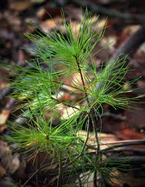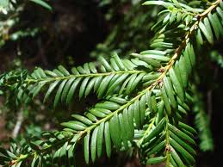

VS

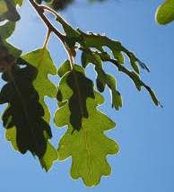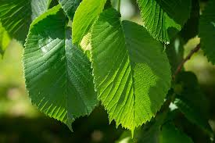

Broad-leafed

Deciduous

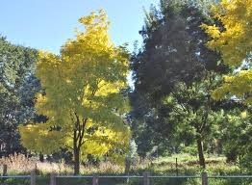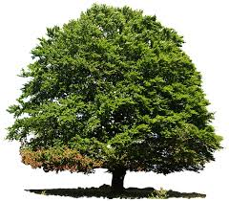

VS

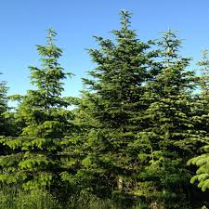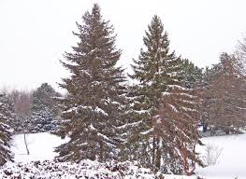

Evergreen

Evergreen or Deciduous?

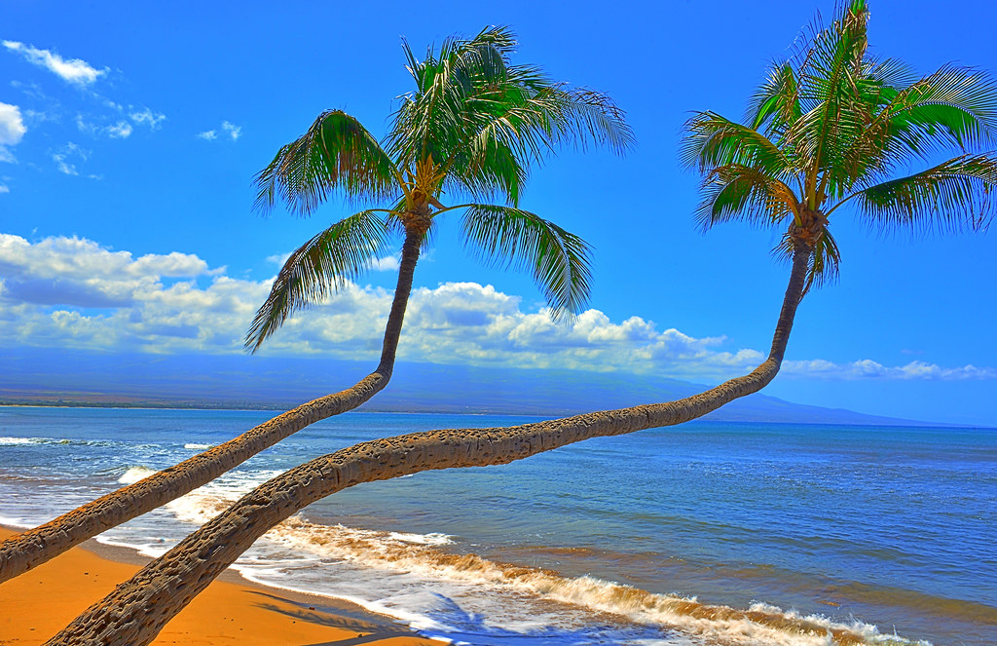

Palm Trees

Evergreen or Deciduous?

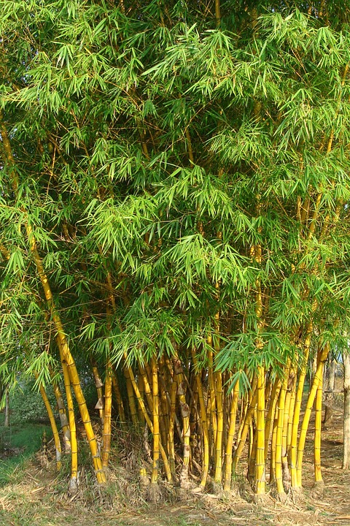

Bamboo Trees

Evergreen or Deciduous?

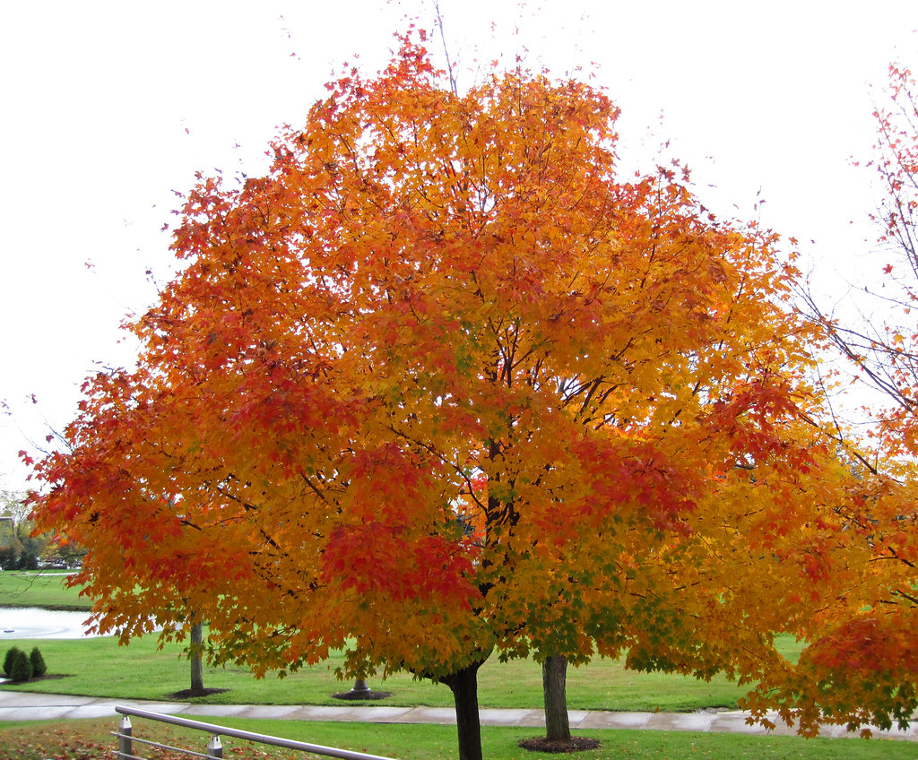

Sugar Maple Tree

Evergreen or Deciduous?

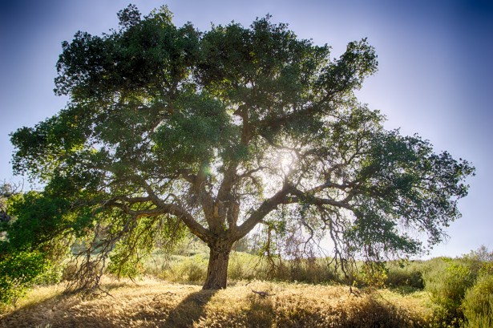

Oak Tree

Evergreen or Deciduous?

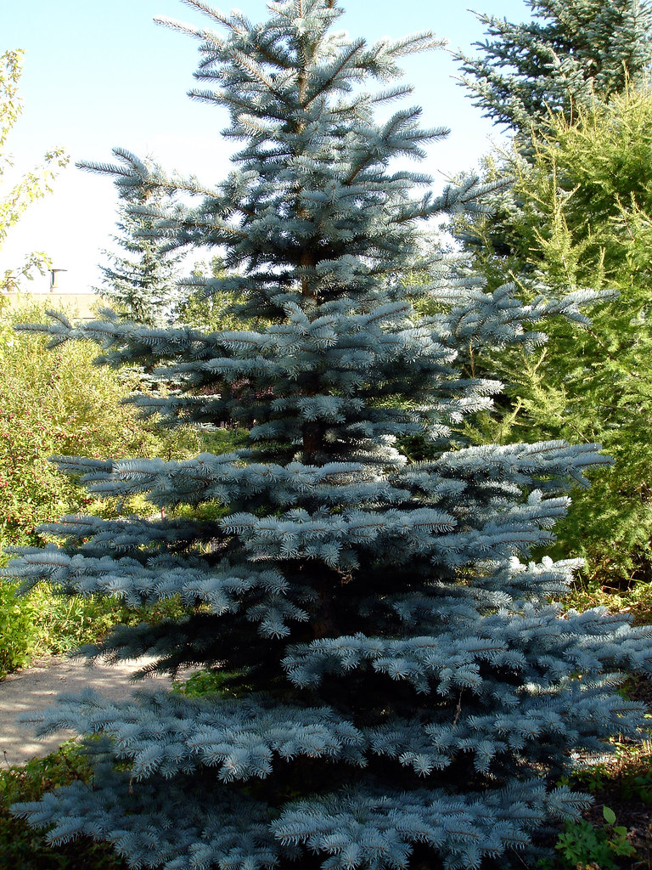

Blue Spruce

Evergreen or Deciduous?

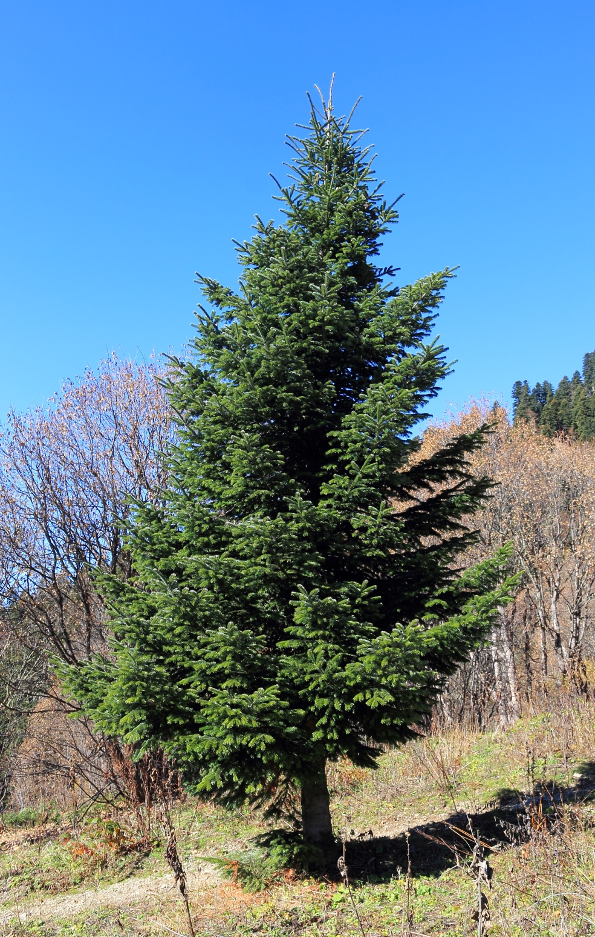

Fir Tree

Evergreen or Deciduous?

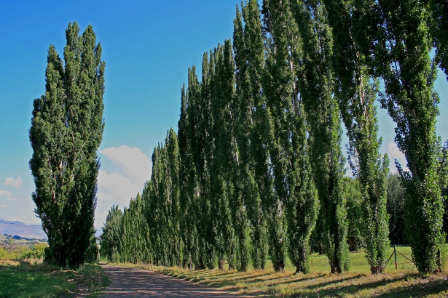

Poplar Tree

Supplemental Materials for Volunteers

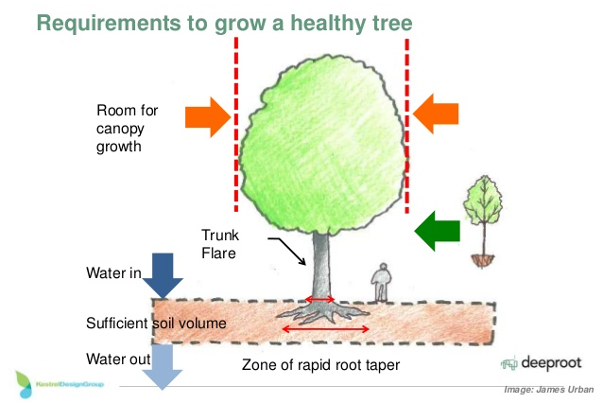

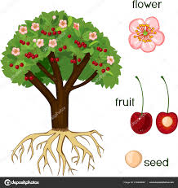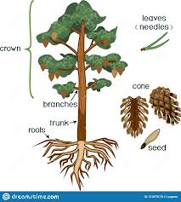

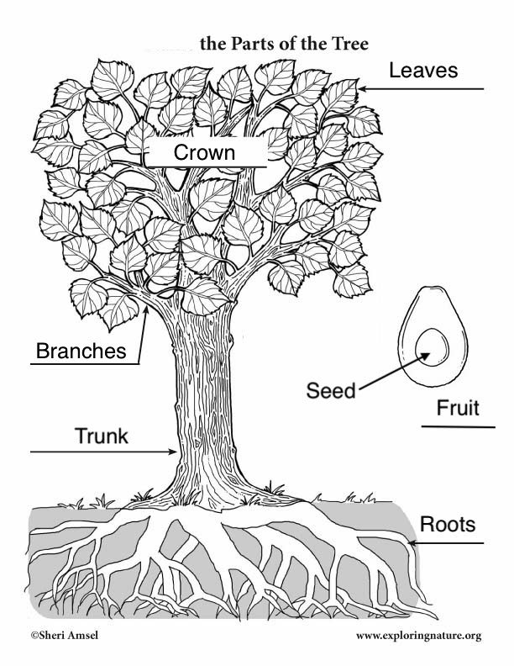

- Simon says “Evergreen”

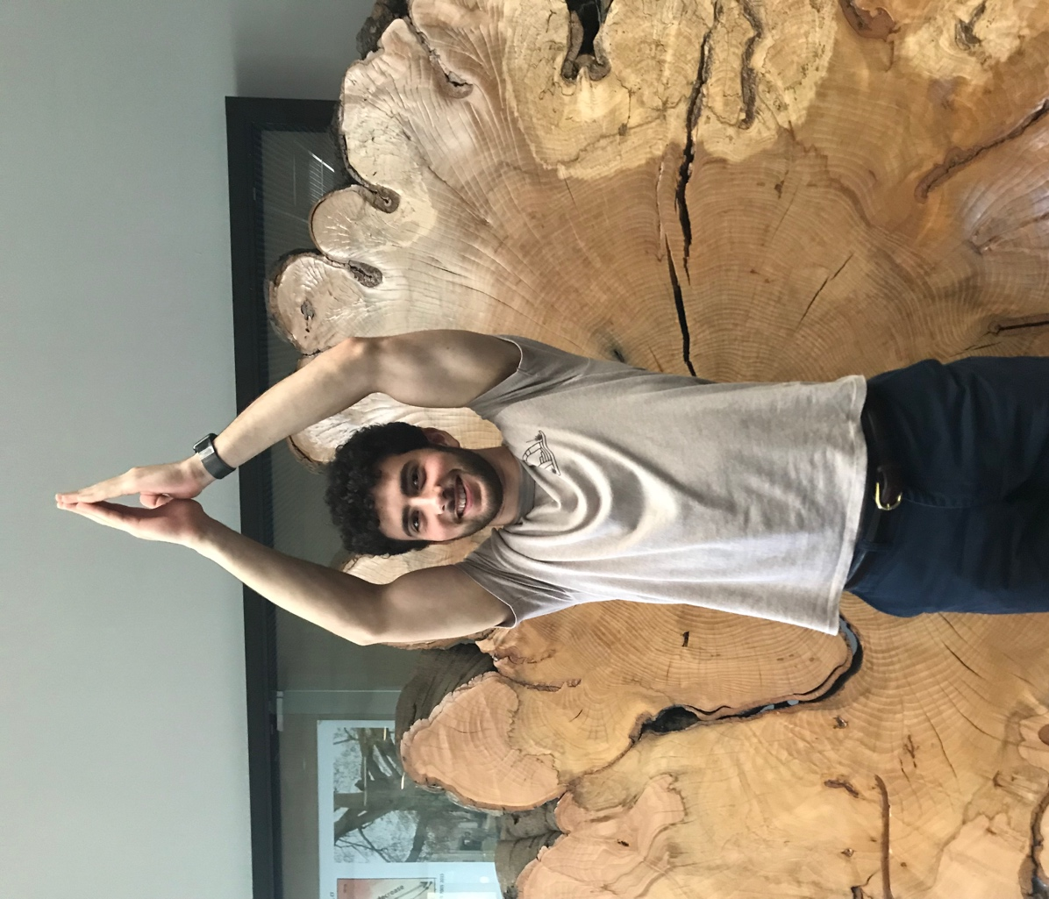

Raise your arms above your head with your palms together, symbolizing the pointed top of many common evergreen trees (i.e. pine).

- Simon says “Deciduous”

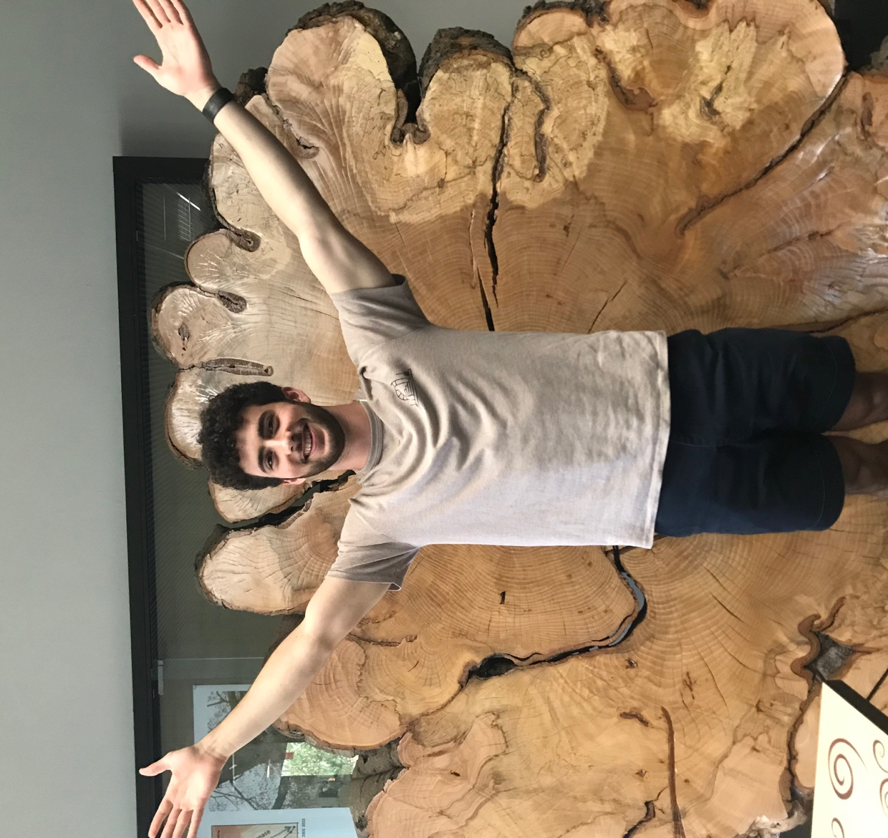

Put your arms out with your hands open/palms facing front to symbolize the more dense foliage/leaves of many typical deciduous trees (i.e. maple) and then do “jazz hands” down to symbolize the trees shedding off the trees during the fall.

- Simon says “Broad-leaves”

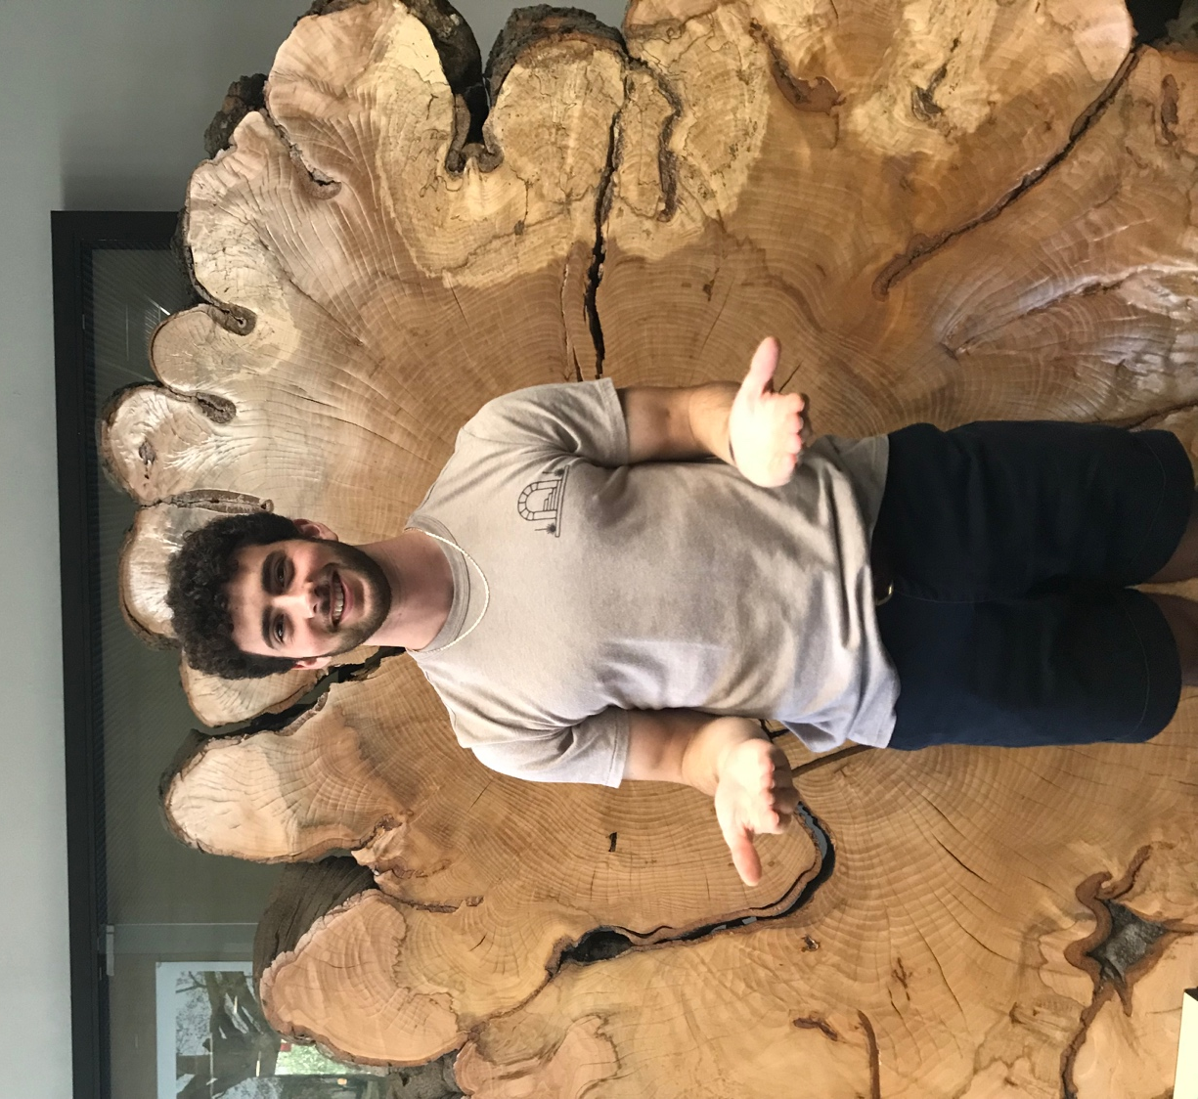

Put your hands out in front of your body, open and with the palms facing upwards, representing broad leaves (if their arms are branches).

- Simon says “Needle-leaves”

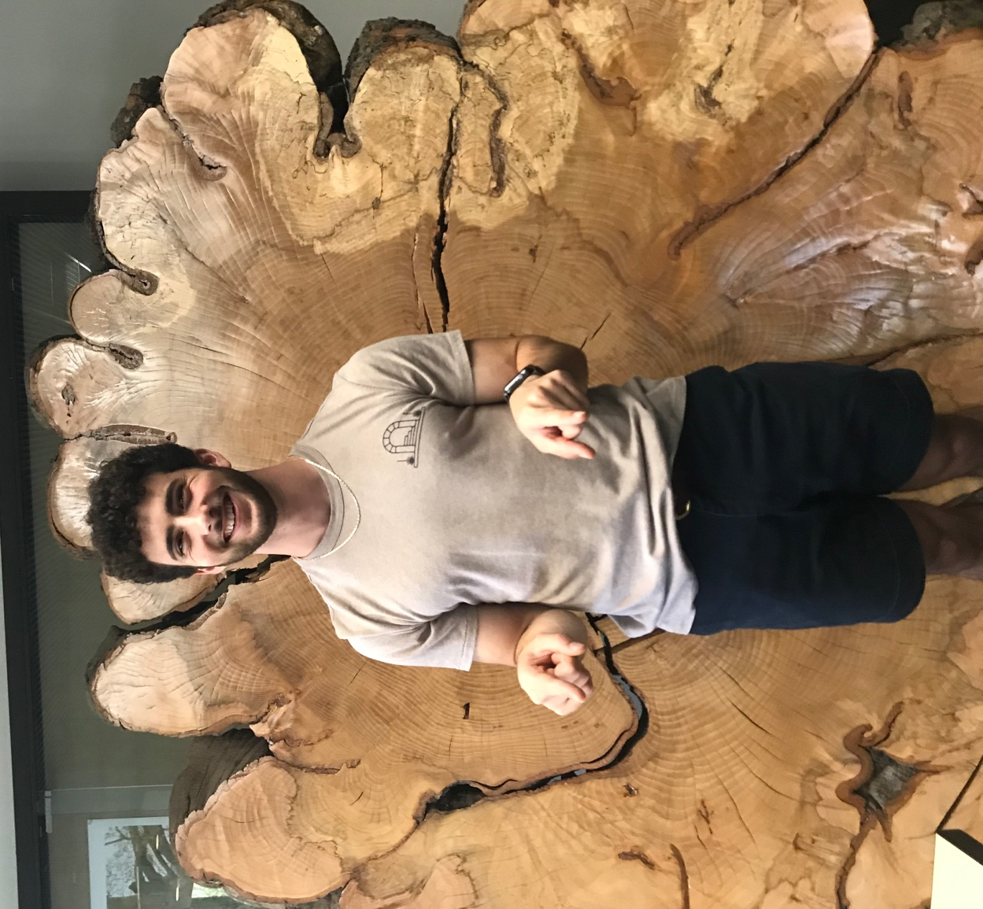

Stay in the same place as with the broad-leaves pose, but your palms should face down and your pointer fingers should point forward to represent the needle shape of needle-leaves.

