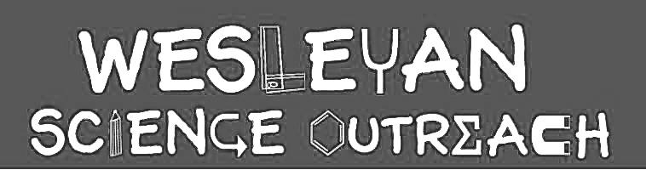

Emily Aoki
10/27/2019

Eyes and Vision

This lesson plan is an updated version of a plan from spring 2015. Kids will learn about the anatomy of an eyeball, observe how their pupils dilate in response to light, and test their depth perception and peripheral vision.

Material List
Key Words

- Retina
- Lens
- Pupils
- Peripheral
- Depth

- Compound eye glasses
- Eye model
- 20 Mirrors
- Cups
- Foam balls
- Colored construction paper

Activities

1. Introduction
Duration: 5 min.

Ask kids what they know about eyes. Show the kids the eye model. Point out the muscles on the top/bottom/sides. The eye uses muscles just as the arms and legs do. Why might an eye need muscles?
The muscles in your eye help to focus your vision. They allow you to look around without turning your head, or even cross your eyes. (Demonstrate if you want to) Does anyone know what a pupil is? It’s the black spot in the center of your eye. Did you know it’s actually a hole?
The inside of your eye is filled with fluid, which is a lot like water. Your eye works by letting light in through your pupil, which hits the back wall of your eye, called the retina. Then your brain processes the information from the light and shows you what you see in front of you.
Ask the kids if they know anyone that wears glasses. Explain that, just like how glasses have lenses, your eyes have a clear cover over the pupil, also called the lens, to protect the opening of your pupil and to help focus your vision on certain objects. Did you know different animals can have different eyes and lens?

Ask the kids if they have ever seen fly eyes. Why might different animals have different eyes? How are fly eyes better than human eyes? How are they worse?
Show them the pictures of the fish and the hawk. Are their eyes in the same or different places? Why might they be in different positions?
Flies have “compound eyes,” so their eyes are made up of lots of small lens put together. Show the kids the picture of the fly eye and the view of a flower through a butterfly’s eyes.

2. Pupil Dilation Test
Duration: 10 min.

Have the kids take a look at their own eyes with mirrors. What happens when they close their eyes for 10 seconds, and then open them? Their pupils will have dilated!
Eyes need light in order to see, and when there is less light, your pupils will get bigger in order to let in more light. When your pupil is larger and more open, it is “dilated.” When we are in the dark or when our eyes are closed, the muscle works harder to help us see by making the pupil bigger.
Muscles control how our eyes function, much in the same way that we use muscles for other things, like moving our arms.

3. Depth Perception Test
Duration: 15 min.

Pair up the kids and give each pair a plastic cup and a foam ball. Have one kid watch as the other holds a cotton ball and slowly moves their hand towards the cup. When the first kid thinks the cotton ball is right over the cup, they will tell the second kid to drop it in. Let them try a couple of times if they don’t get it right away.
Then repeat the exercise, but this time with the kid holding the cup having their left eye closed. Then repeat with the right eye closed.
The kids should find that they perform better with both eyes than just one. This is because the brain uses information from both eyes to figure out how far away something is, or the “depth” of it in their “field of vision.”
If there’s time, have them try touching the tips of their index fingers with both eyes open, then one eye closed. It should be easier with both eyes open.

4. Peripheral Vision Test
Duration: 15 min.

Either keep the kids in their pairs or have them pick new pairs. Kid 1 should stand still with a clear open space in front of them. Kid 2 will stand behind Kid 1. Once you confirm that Kid 1 can’t see Kid 2 at all, sneakily give them a piece of colored construction paper to hold in front of them. Make sure Kid 1 can’t see it! Then have Kid 2 walk slowly in a semicircle around Kid 1. Kid 1 should say as soon as they can see the paper, and also when they can determine the color of it.
These may be different times. Why is this? Because there are two parts of the eye: one that senses light (rods) and one that senses color (cones). The color-sensors are in the middle of our eyes, but there are not as many on the edges, so it’s harder to see what color things in your peripheral vision are.
Peripheral vision is your vision that is not in your focus. If you hold your hand up in front of you and focus on it, then everything else that’s kind of blurry but that you can still see around it is in your peripheral vision.

Conclusion

The eyes are a very important part of your body, and just like many other parts of it, move with muscles. Your pupils are holes in the center of your eye that let light in, which reflects off the back wall of your eye, the retina, to be recognized by your brain, which is how you see. Your eye muscles help you focus on specific things, and everything else that you see on the sides that is blurry is in your peripheral vision. They also help you see at many different distances, or depths, from where you stand, far or shallow depth.

Instructor Comments

