Call 911, It’s an Emergen-C!!!

FRAMEWORK
- Scientific and Engineering Practices
- Asking questions
4. Analyzing and interpreting data
- Cross-Cutting Concepts
4. Systems and system models
- Physical Sciences
LS 1. From molecules to organisms: Structures and processes

SKILLS/OBJECTIVES
- Learning what vitamins are and how they help our body
- Learning what foods have vitamins in them

MATERIALS
- 1/2 teaspoon cornstarch
- 1 cup water
- Iodine
- More water
- Eyedropper
- Medium sized bowl
- Several smaller bowls
- Crushed vitamin C tablet dissolved in 1 cup of water
- Various beverages: orange juice, soda, cranberry juice, grapefruit juice, and Gatorade
- Fruit Fact Worksheet
- 2-3 cups fortified cereal
- Magnet
- Bowl
- Spoon or other utensil
- Water
- Blender (optional)
- Napkin/paper towel

BACKGROUND
- Do you guys know what germs are? Well, what happens when germs invade our bodies? How come we don’t always get sick? How do we protect ourselves?
- We have a natural defense force in our bodies called our immune systems. Immune systems are like little soldiers inside our bodies that fight against the “bad guys.” Immune systems aren’t always naturally strong enough to fend off all the germs that we come in contact with all day. So, in order to make sure we stay healthy, we have to make our immune systems strong. What do you think makes our immune system strong?
- Vitamins! Do you know what vitamins are? Our immune systems love vitamins. Vitamins protect us from getting colds, coughs and stomachaches. It’s like having our own personal army!

Activity # 1 | Vitamin C Experiment: Test the amount of vitamin C in different substances
Materials | - 1/2 teaspoon cornstarch  - 1 cup water  - Iodine  - More water  - Eyedropper  - Medium sized bowl  - Several smaller bowls  - Crushed vitamin C tablet dissolved in 1 cup of water  - Various beverages: orange juice, soda, cranberry juice, grapefruit juice, and Gatorade  * Prepare experimental mix before class
Worksheet | No

- A lot of vitamins have “boring” names. Some of them are named after the alphabet. There’s Vitamin A, B, C, D, and E! Every day you eat something with these vitamins in it, which help us grow big and strong.
- Right now we’re going to do an activity that helps us see how much Vitamin C is in the food we like to eat.
- Do you know what Vitamin C is for? Do you know what foods have Vitamin C in it?
- Vitamin C helps the body heal itself from within- it helps our cells stay healthy and fixes the cells that are wounded. Vitamin C is also really important for our immune systems (remember what the immune system is?); it’s sort of like super-food for our immune cells.

I think it would be important to start the lesson with explaining what makes a vitamin a vitamin: (1) It is essential for normal human growth and nutrition, 2) The body cannot make it on its own, and 3) It is an organic compound. And explain why this is the reason that it is important to eat foods that are vitamin rich.

- There is a lot of vitamin C in orange juice, and that’s why it’s important to drink orange juice when you’ve got a cold. Let’s see what other stuff has vitamin C in it!
- Mix ½ teaspoon cornstarch into 1 cup cold water; dissolve mixture by heating.
- Measure 1 cup of water into a bowl and add 1 teaspoon of the cornstarch mixture. Using an eyedropper, add 4 drops of iodine and stir.
- The mixture should be a pale blue. Prepare mixture before class. During experiment, introduce it as the “magic vitamin c indicator solution”.
- Put 2 tablespoons of the “magic vitamin c indicator solution” into several small bowls. Using a clean eyedropper add the vitamin C solution to one of the blue mixtures. In another bowl add orange juice, another orange soda, etc. Make note of how many drops it takes before the blue color to disappear.
- Only foods with vitamin C will make the blue color disappear. The punch and orange soda do not have vitamin C. If a food does not have vitamin C, the solution will not change color.
- So when you are feeling sick, should you have juice or orange soda?
- From the results of our experiment, we know that all of the fruit drinks contained vitamin C. This tells us that fruit is an excellent source of vitamins! What other vitamins are found in fruit?
We can do this activity with a small amount of juice and soda.

Activity # 2 | Match the Vitamin to the Fruit Game
Materials | - Fruit Fact Worksheet
Worksheet | Yes

- Introduce worksheet with information about fruit on one side and information about vitamins on the other.

- Vitamin Facts:
Vitamin A makes our hair, skin and teeth strong. It also helps with vision.
Vitamin B helps us convert the food we eat into energy we can use to stay active.
Vitamin C makes our immune systems strong, and helps protect us from getting sick.

- Vitamin D helps us absorb calcium from food, which makes our bones strong.
Our bodies have a very special way of getting vitamin D. Does anyone know how we do this? Our skin is able to absorb vitamin D from sunlight! How long do you think it takes for our skin to absorb enough vitamin D so that we can grow big and strong? 10-15 minutes everyday. This is why it is important to spend time playing outside.
- Vitamin E makes our skin strong, and helps heal our cuts and scrapes.

Fruit facts:
Mango: Improves eyesight
Banana: Increases energy
Strawberry: Heals coughs and colds
Blueberry: Protects cell membranes (Just like there are walls around a castle, there are walls around our cells to keep all the important stuff in them protected, sort of like a cell’s skin)
Milk: Strengthens bones

Introduce a mango, banana, strawberry, and blueberry. Most fruit contain many vitamins but some fruits are higher in certain vitamins than others. Guess which fruit has high amounts of vitamin A, B, C, D and E.

Answer key:
Vitamin A = Mango
Vitamin B = Banana
Vitamin C = Strawberry
(Vitamin D = Milk) *Explain that milk is great source of calcium, but we need vitamin D in order to absorb calcium. We can get vitamin D from foods like fish and mushrooms, and also from the sun.
Vitamin E = Blueberry

For this lesson plan we might want to omit the minerals activity as this lesson plan is intended to be focused on vitamins.

We can replace it with a memory/matching game. In this game, instead of matching two identical images together, they can match an image or description of a task such as “improve eyesight, strengthen bones, colds, etc.” and then match it with another card that has the name of the appropriate vitamin for that description.

This lesson plan does not include an activity where they can make something that they can take home. Not necessary but would be a fun addition.

CONCLUSIONS

Vitamins and mineral are all around us, and they are very important for staying healthy. If you eat fruits and vegetables and cereal, you can get the vitamins you need!

Vitamin Matching Activity

Vitamin A makes our hair, skin and teeth strong. It also helps with vision.
Vitamin B helps us convert the food we eat into energy we can use to stay active.
Vitamin C makes our immune systems strong, and helps protect us from getting sick.
Vitamin D helps us absorb calcium from food, which makes our bones strong.
Vitamin E makes our skin strong, and helps heal our cuts and scrapes.

Mango: Improves eyesight 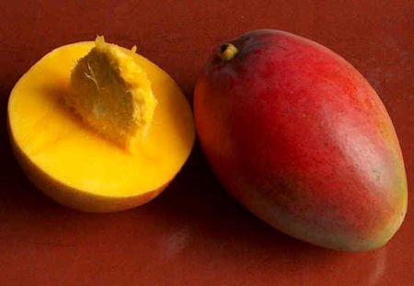
Banana: Increases energy 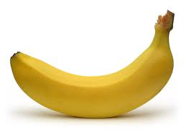
Strawberry: Heals coughs and colds 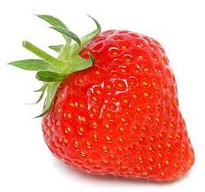
Blueberry: Protects cell membranes 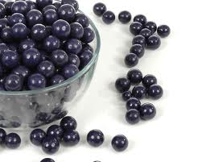
Milk: Strengthens bones 