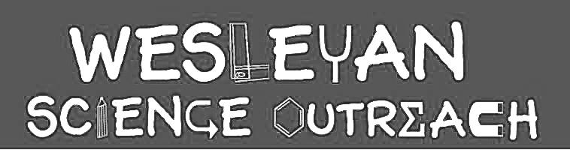

Julia Perry
1/28/2019

Vision

Kids will learn about how we see images, from sensation (with the eyes) to perception (with the brain). First, kids will learn about eye anatomy and how different parts of the eye work together to gather information from the environment. Then, kids will learn about how the brain puts together information to allow us to interpret our surroundings.
Key Words

- Sensation
- Perception
- Sclera
- Iris
- Pupil
- Optic Nerve
- Retina
- Lens
- Cornea
- Optical Illusion

Material List

- eye model
- fill-in-the-blank eye worksheets
- pictures of animal and insect eyes
- bug eye glasses
- optical illusion cards

Activities

1. Introduction and Human Eye Anatomy
Duration: [15 min]

Who can name the five senses? (wait for responses) Today, we’re going to talk about one sense in particular – vision. Who knows what body part we use to see? (the eyes) When we see an image, the eye takes in light from our surroundings. This is called sensation. Then, the eye sends information about what it saw to the brain, which puts together the images and helps us to understand what we’re seeing. This is called perception.

If the class is large, break the class into two groups (one will start with the eye model and one will start with the eye anatomy diagram worksheets). If the class is small, go over the eye model first with the whole class and then go through the eye anatomy diagrams.

- Show the kids the eye model, points of emphasis:
  - Pupil: the hole though which light enters the eye; appears black because the light rays entering the eye are absorbed by the tissues in the eye
  - Iris: the colored part of the eye
  - Cornea: the outer clear, round structure that covers the iris and pupil
  - Sclera: the white part of the eyeball
  - Lens: like glasses the lens focuses on the image (can move a little forward or backwards)
  - Muscles on the top/bottom/sides: the eyes have muscles, just as the arms and legs do
  - The retina (take the eyeball out for this) is the dark part in the back, the light hits this part of the eyeball, and the information taken in is sent to the optic nerve
  - Optic nerve (sticking out at the back of the eye): sends signals from the eye to the brain

- Hand out eye anatomy diagram worksheets. Have the kids complete the worksheets in groups with a volunteer leading each group. Once done with labeling, they can color in the eyes.
- Once everyone is done with the worksheet, go over the answers with the whole class.

2. Comparing Human and Animal Eyes
Duration: 10 min

Not all animals have eyes that look like human eyes. Other animals’ eyes look different, so they see differently.

- Break the class into groups, with one volunteer leading each group. Distribute pictures of human eyes, fly eyes, and various other animal eyes.
- Note differences and similarities between the eyes.
  - Bug eyes – compound eyes made up of tiny units called “ommatidia”
  - Cuttlefish – have W shaped eyes; they are colorblind but they can see polarized light that is invisible to humans
  - Zebras - have eyes located on the sides of their head – this gives them a wider field of vision, which they need because they are prey animals and need to see possible predators
  - Eagles – have eyes located on the front of their head; eagles have very good vision – if you swapped your eye’s for an eagle’s, you could see an ant crawling on the ground from the roof of a 10-story building
- Questions to consider asking: why would different animals have different eyes? What is helpful about some of these eyes?
- Pass around the bug eye glasses for the kids to try on

3. Optical Illusions
Duration: 20 min

When we see something, our eyes take in light and sense the image. Does anybody remember what the word is for when the brain interprets the information that our eyes take in? (perception)

We’re going to learn more about perception by looking at some optical illusions. Does anybody know what an optical illusion is? How do they work? Optical illusions are images that are deceiving to the brain. They work by tricking your brain into perceiving the image in a certain way.

- Break the class into groups, with one volunteer leading each group.
- Distribute the optical illusions cards and have the kids look at them and go over them.
- At the end, distribute paper and markers so each kid can design their own optical illusion.

Conclusion

In this lesson, we learned about the two components of vision: sensation and perception. We learned about how the different parts of the human eye work together to gather information from the environment. We looked at the eyes of other animals and learned about how they see differently. Finally, we learned about how the brain perceives images by looking at different optical illusions and creating our own.

Instructor Comments

Depending on the group, the kids might get competitive with the bug eye glasses, since there aren’t enough for each kid to have their own. Make sure they’re taking turns and direct them as needed.

