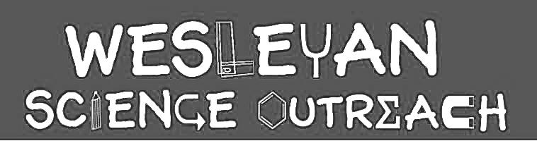

Samantha Schreiber
October 2, 2018

Animal Adaptations!

The goal of this lesson is to teach students about the concept of adaptation by focusing on different animal adaptations. In order to do this, students will first learn about predators vs. prey and learn how to classify an animal into one of those two categories. They will then learn about behavioral vs. physical adaptations through both drawing and movement.

Material List

- Laminated pictures of animals: rabbit (prey), deer (prey), cheetah (predator), and crocodile (predator)
- Chart paper
- Tape (to hang chart paper)
- Space large enough to stand up and act animal movements out
- Paper
- Markers
- 6 sets of 7 pictures of different physical adaptations animals have: 1) eyes on front of head, 2) eyes on side of head, 3) sharp teeth, 4) really sharp claws, 5) tiny claws, 6) larger ears, 7) short ears
- Sticker magnets (for drawing activity)

Activities

1. Intro to Adaptations
Duration: 10 minutes

Today we are going to learn about adaptations. Has anyone ever heard of the word adaptation before? Turn and talk to the person next to you about what you think an adaptation is. Walk around and listen to what they’re saying. Compliment all of the good ideas but say you’re going to repeat what it is for everyone to hear. An adaptation is any physical characteristic or behavior that allows an animal to live and thrive in their environment (the place that they live). Today we have four pictures of different animals. Hold the pictures up one by one have the kids point out the different features they notice (teeth, arms, tails, eyes, etc.) and have them elaborate (can you say more about that?). Have a co-leader or volunteer hang the chart paper and list all of the different attributes that the kids notice. Make four different lists—one for each animal. Then have the students notice similarities between the lists for the cheetah and the crocodile—these are what we call predators. Then have them notice the similarities between the rabbit and the deer—these are what we call prey.

2. Learning about Predators vs. Prey
Duration: 10 minutes

A predator is an animal that kills other animals for food. A prey is an animal that gets eaten by other animals. Split the students into smaller groups (4 students per group if allowable with materials) and present them with the piles of adaptation pictures. Say: now we are going to see if we can tell which adaptations belong to predators and which belong to prey. Decide as a group what adaptations belong in the predator pile and what belongs in the prey pile. Make sure that you discuss these decisions as a group before deciding which pile to put the pictures into. After a 5-6 minutes have them come back together. Have volunteers hold up the different pictures one by one and have the kids call out predator vs. prey and put them into piles. If there seems to be a lot of variance in the answer, talk about it as a class.

3. Acting out Predators vs. Prey
Duration: 15 minutes

In the last activity, we were looking at the physical adaptations of predators and prey. During this activity we are going to switch over to the behavioral adaptations and you guys are going to do this by acting out the different behaviors for predators and prey. For this activity we will split the kids into partners. One will be a predator and one will be a prey. MAKE IT CLEAR THAT NO ONE WILL EVER ACTUALLY TOUCH HIS OR HER PARTNER. Students will quickly decide which partner will act out predator behaviors and which partner will act out prey behaviors. Throughout this activity the leader will verbally guide the students through the steps. During this time, the volunteers should walk around and take notice of these behaviors as well. They should feel free to question student’s choices of behavior as they go around. Teacher tells predator students to take a few seconds to think about the behaviors they need to show in order to catch their prey. Students who are acting as the prey will watch their partners and notice how their partners are behaving (what they are doing). Teacher will tell predators to stop and have the prey share what they observed/noticed. Now it’s the prey’s turn to act out their behaviors in response to what they predators did. This time the predators should observe the behaviors of the prey and when the teacher says it’s time to stop, they will share out what they noticed. This can be followed by a short discussion about why prey and predators act in a certain way. Are there any ways in which their behaviors overlap? Predators usually have very slow movements (stalk their prey), pouncing, camouflaging, and jaws snapping. Prey usually have faster movements (running away), camouflaging, standing very still, and playing dead.

Do activity again and have the students switch roles!

4. [Drawing Predators vs. Prey]
Duration: 10 minutes

Now that we’ve seen both physical and behavioral adaptations, we are going to create our own predators and prey. Choose either a predator or a prey and at least use the different adaptations we noticed earlier to create your own. Feel free to incorporate other adaptations that may not have been noticed or mentioned earlier. For older kids, have them list the different adaptations on the side of their papers and why they chose to give their animals these adaptations (long neck for reaching food or sharp claws for hunting prey).

Conclusion

Today we learned about adaptations through the lens of predator vs. prey. We learned that every physical and behavioral characteristic that an animal has, has a specific purpose. These adaptations are essential because adaptations allow animals to survive in their habitats.

If students finish early, have them draw whichever type of animal they haven’t drawn yet!

Instructor Comments

The reason that I chose these animals is because they very literally demonstrate the adaptations that are important for predators and prey. Predators need eyes on the front of their heads because they focus in on prey; prey need eyes on the side of their head because this gives them better peripheral vision and a better chance of seeing an attacker.

Have the kids continue to draw if the lesson ends too quickly!
Print pictures on separate pages!

Supplemental Materials for the Intro Activity
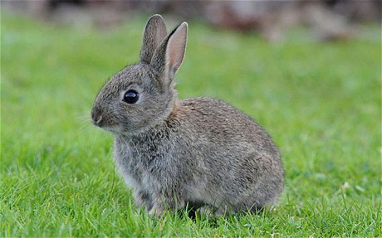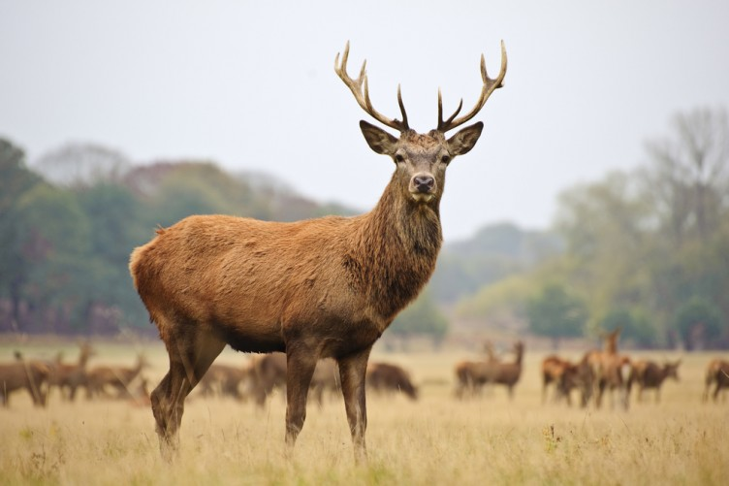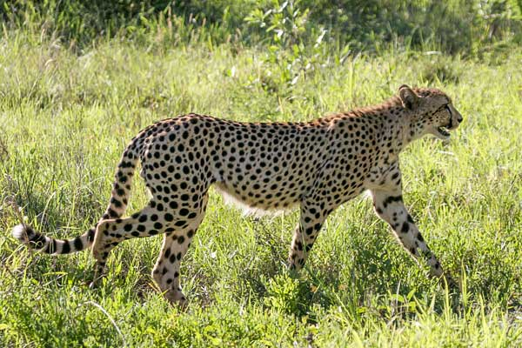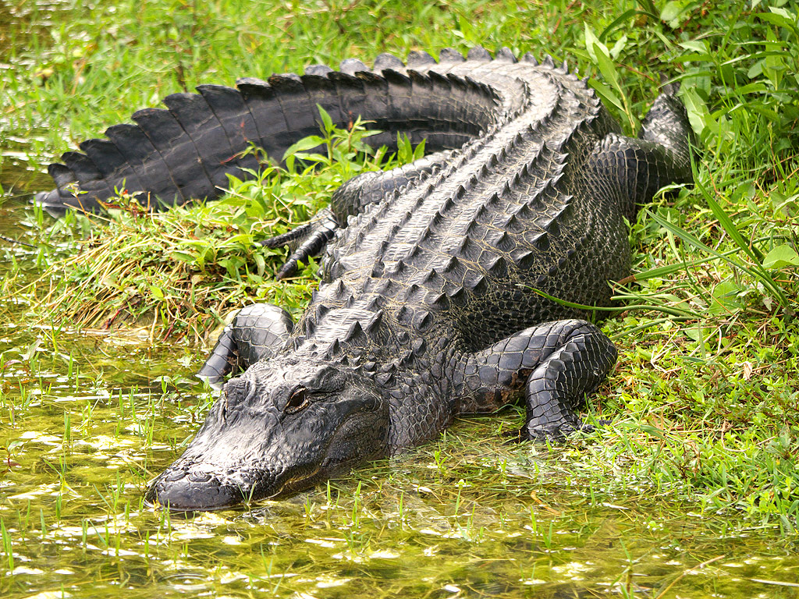

Supplemental Materials for the Predator vs. Prey activity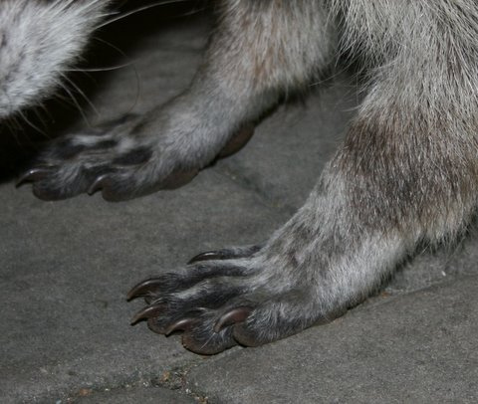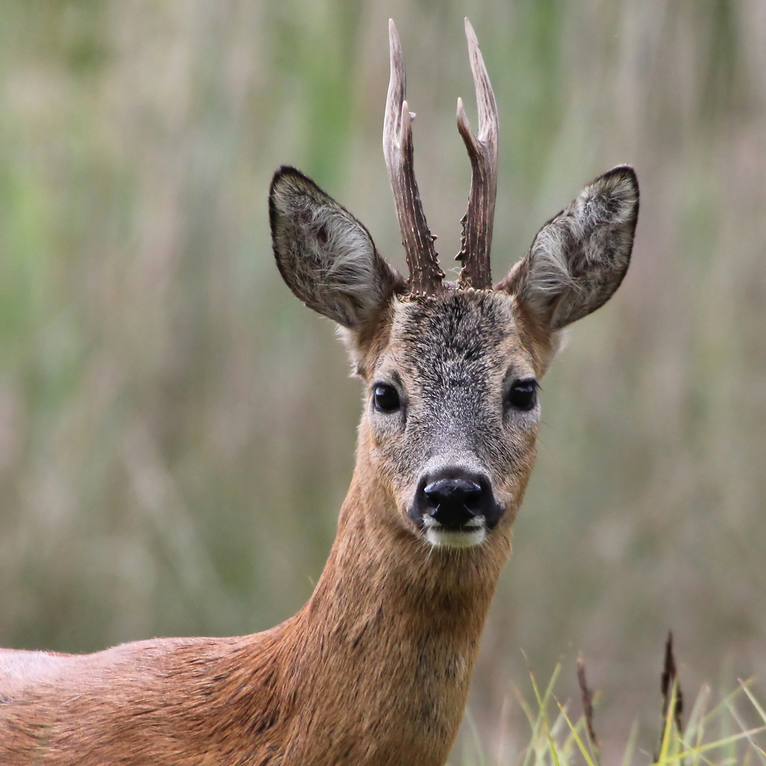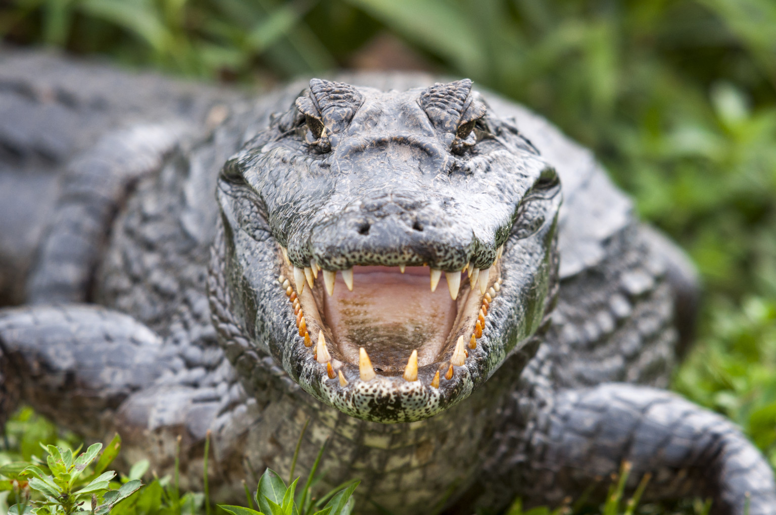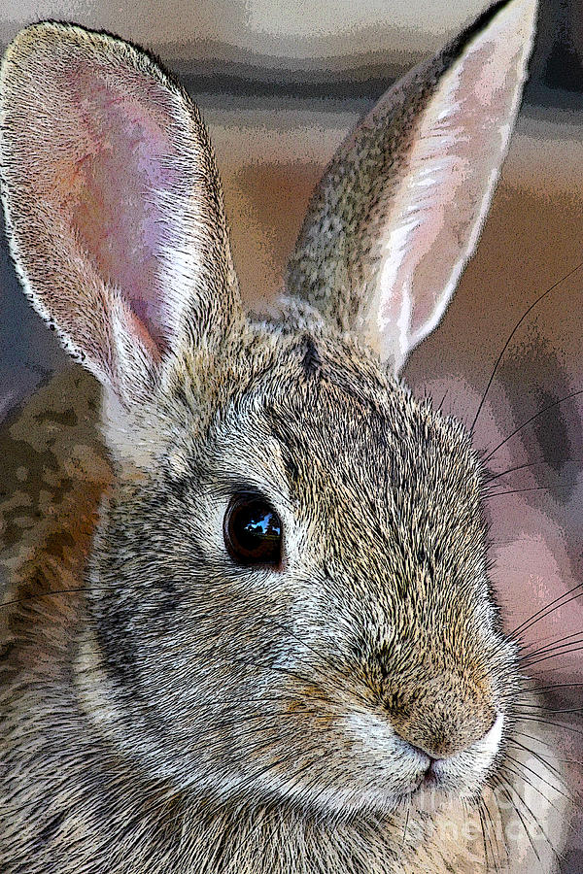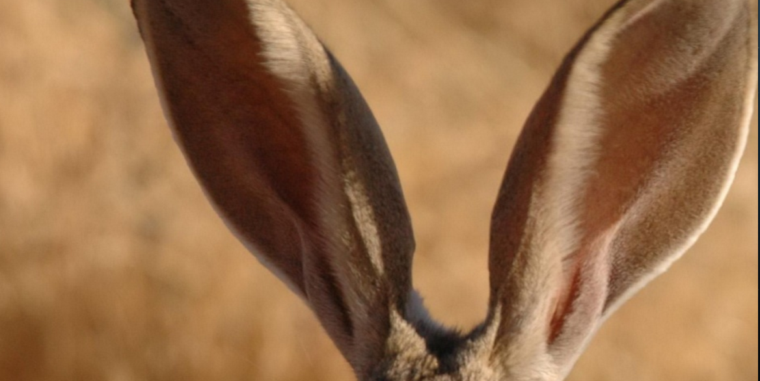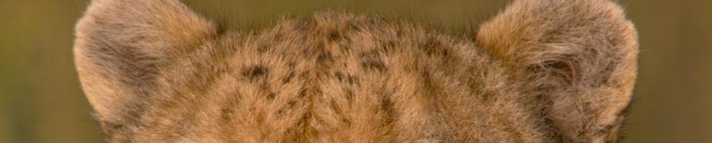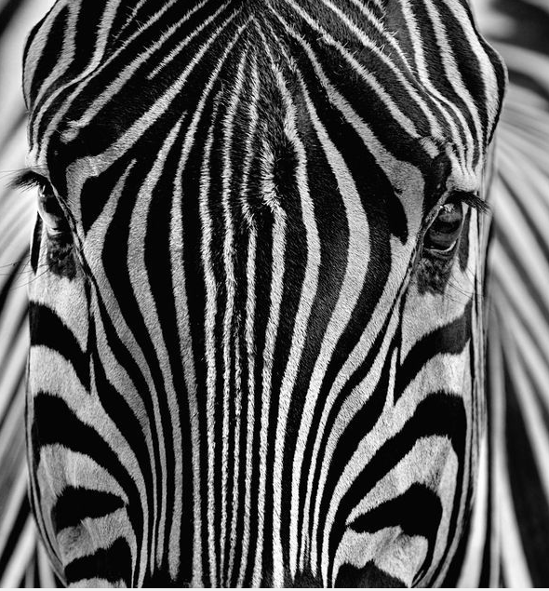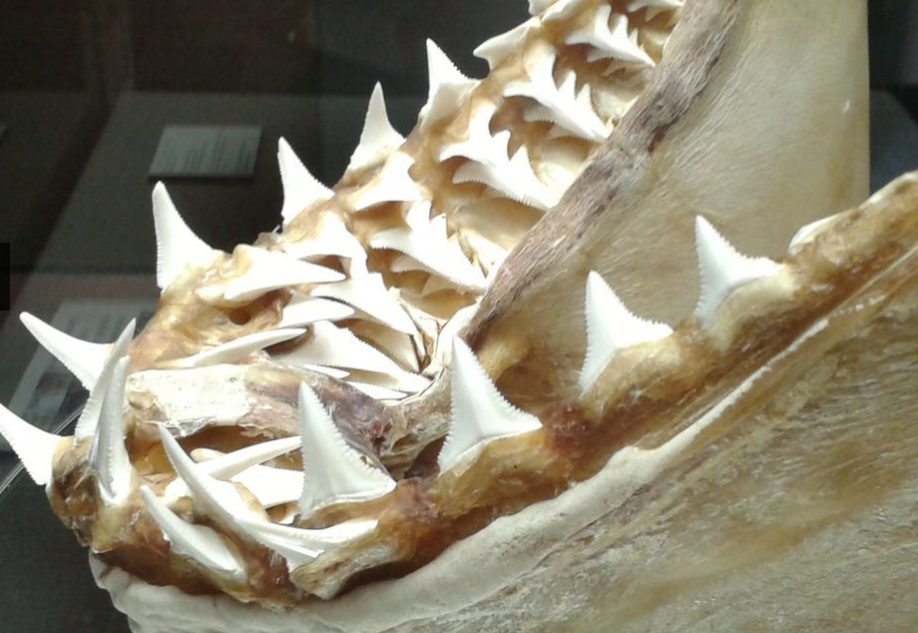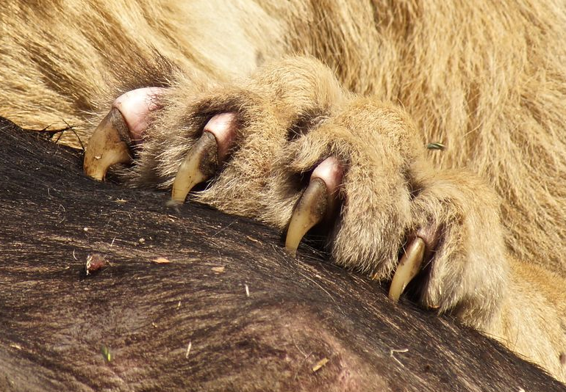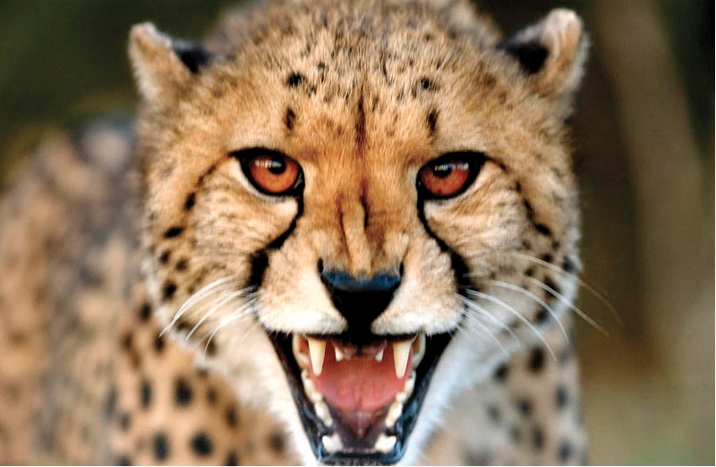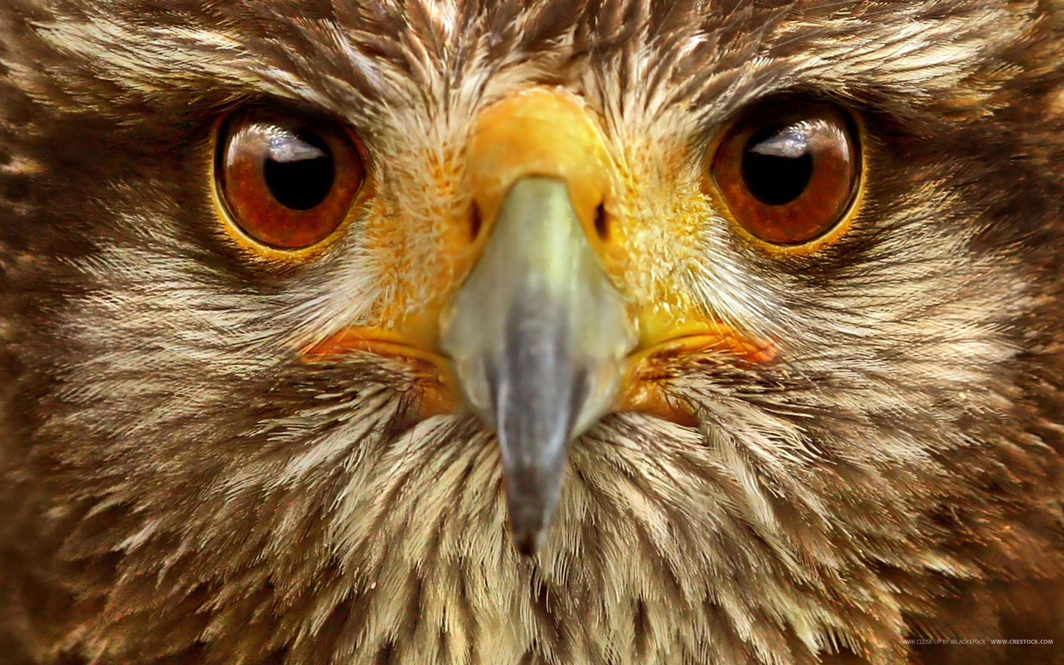

Predator Adaptations
- Big and Sharp Claws
- Sharp Teeth
- Eyes on Front of the Head
- Powerful Legs to Help Run Fast
- Able to Camouflage into Surroundings

Predator Adaptations
- Big and Sharp Claws
- Sharp Teeth
- Eyes on Front of the Head
- Powerful Legs to Help Run Fast
- Able to Camouflage into Surroundings

Predator Adaptations
- Big and Sharp Claws
- Sharp Teeth
- Eyes on Front of the Head
- Powerful Legs to Help Run Fast
- Able to Camouflage into Surroundings

Prey Adaptations
- Small Claws for Climbing and Eating
- Smaller Teeth (can still be sharp, but usually not the first thing you notice)
- Eyes on Side of Head
- Able to Camouflage into Surroundings

Prey Adaptations
- Small Claws for Climbing and Eating
- Smaller Teeth (can still be sharp, but usually not the first thing you notice)
- Eyes on Side of Head
- Able to Camouflage into Surroundings

Prey Adaptations
- Small Claws for Climbing and Eating
- Smaller Teeth (can still be sharp, but usually not the first thing you notice)
- Eyes on Side of Head
- Able to Camouflage into Surroundings

