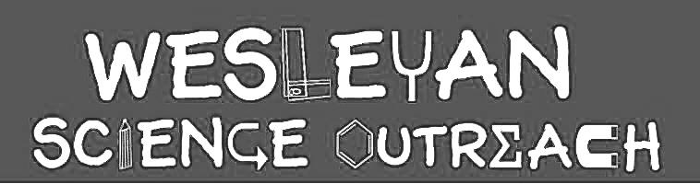

Kayla Jaikaran
10/3/18
The Respiratory System

The goal of this lesson is to teach students about the respiratory system and its role in breathing. In order to do this, students will first be introduced to the respiratory system and its basic components. They will then be able to demonstrate knowledge of the paths that oxygen and carbon dioxide take during inhalation and exhalation. They will also demonstrate and observe respiratory processes and functions through hands-on modeling.

Material List
Key Words

- Respiratory System
- Lungs
- Oxygen
- Carbon Dioxide
- Trachea/Windpipe
- Bronchi

- Worksheets
- 5-6 Plastic balls
- Relay Name Tags
- 2 Small balloons per student
- 1 plastic straw per student
- 1 Y-shaped tube per student
- Rubber bands

Activities

1. Intro to the Respiratory System
Duration: 10 mins

Can anyone name our body systems? Wait for a student to name the systems and mention the respiratory system. Tell them that today we are going to be learning about the respiratory system. Ask the kids what that is or what it helps us do. It helps us breathe! Can anyone name any respiratory system parts? Talk about the parts of the respiratory system and what they do. Pass out pictures of the respiratory system.
Nose: This is where air enters out bodies!
Mouth: Most of the air we breathe in goes in through our noses, but some air can go in through our mouths!
Trachea/Windpipe: Long tube that goes down our necks and connects our mouths to our lungs. The air travels down this tube from our mouths to our lungs.
Bronchi: The large air tubes leading from the trachea to the lungs
Lungs: We have two. Our air is stored here and the oxygen in our air can be carried from here to the rest of our bodies.
Talk about inhaling an exhaling. We inhale oxygen and that goes through our respiratory tract and to our bodies. When we exhale we release Carbon Dioxide and it goes up our tract and out of our bodies.
Have the kids take a few slow breaths to demonstrate.

2. Worksheets
Duration: 10 mins

After learning the basics of the respiratory system, the students will now receive a worksheet about the path our breath takes in our body. The worksheet will include a simple diagram of the respiratory path and students will have to label the steps of the path. Volunteers will walk around and help and club leader will go over the path with the whole class. (If there is extra time, students can color in the image of the respiratory parts.)

3. Respiratory Relay
Duration: 10 mins

Now that we know the path our breath takes through our respiratory system, we are going to put that to the test! Students will be in groups of 5 (If this isn’t possible, volunteers can join groups and participate!) sitting in a circle. Each student will get a name tag with a part of the respiratory system on it. Tell the kids that they represent whatever organ/component is on each tag. The first student in each circle will get a small ball. Then, going around in a circle, each student will read their tag and say briefly what their function is. (Make sure the first student who reads will have the nose card.) The student will then say the body part that they think comes next and toss the ball to the student who represents that next step in the respiratory process (mouth). They will repeat the process, tossing the ball from person to person to match the order that oxygen would travel inside our bodies as we inhale. When this is over, we will switch to exhale, and the students will go in reverse. We can make this a game and have the groups compete over who can keep the ball in the air (without stopping for a mistake) for the longest or compete over how many “breaths” (cycles of inhaling/exhaling) in 2 minutes.

4. Lung Model
Duration: 15 mins

Which part of the respiratory holds our air for us? Lungs! Now we are going to be constructing our own pair of lungs so we can visualize what happens when we breathe in and out. Volunteers should pass out materials while club leader explains activity. Each student should receive 2 small balloons, 2 paper straws, and a Y-shaped tube. Glue sticks, scissors, and tape will be shared among kids or handled by the volunteers. Volunteers walk around tables and keep a close eye on the students because this construction can get a bit messy. First, insert a straw into each balloon and. Tape the straw to the inside of the balloon to keep it from slipping out. Tightly wrap tape around the bag to make it like a lung with bronchial tubes. (Do this for both balloons.) Push both straws into the Y tube. Tape if needed. When the construction is done, instruct the students to try their lungs out! Have them play around exhaling and inhaling.

Conclusion

Today we learned about the respiratory system and the path our breath takes when we inhale Oxygen and exhale Carbon Dioxide. All of these parts are important in breathing.

Instructor Comments

Make sure the kids know they can take their lungs home with them! Encourage them to discuss what they learned and to demonstrate their lungs for their family. Youngers may need some additional assistance with the construction of the lungs, so volunteers should focus on them.

