Andrea Aware
10/14/18
What is an Insect?
The goal of this lesson is to teach students about what defines an insect and the different roles that they can serve. Students will be introduced to the basic anatomy of insects and will be allowed to label different animals as insects or non-insects. They will be taught some of the functions that insects have in our environment and will be able to act them out. Finally, they will demonstrate their knowledge of what makes up an insect by building their own model of one.

Material List
Key Words

- Abdomen
- Thorax
- Antennae
- Insects
- Pollination
- Producers
- Insect anatomy worksheets
- Insect/Non-insect chart
- Insect and animal toys
- Images of insect roles
- Insect cards
- Pipe cleaners
- Googly eyes
- Play dough

Activities

1. Introduction to Insects
Duration: 15 mins

Today we will be learning all about insects. We will learn about their different parts and roles. Ask students if they know any types of insects. Explain that sometimes, many of the small creatures that we often call bugs or insects are not actually insects. Ask them if they know what makes an insect an insect. Explain to them that insects have a specific combination of parts that make them up. Ask them if they know what insects do? Are they helpful or are they bothersome? Explain that many insects have jobs that help us, the environment, and other animals.
Have students fill out a worksheet where they are to label the different parts of an insect’s anatomy. This includes the abdomen, thorax, head, six legs, antennae, and sometimes wings. After they finish labeling, go over the different parts and what they do.

Head – Has the eyes, the mouthparts, and the antennae. The antennae are long, and they help insects “feel” and sense things around them. With their antennae insects can taste, touch, and smell things.

Thorax – The middle of the insect’s body which typically contains the legs. All insects have six legs. (Spiders are not insects because they have 8 legs. They are arachnids. Worms are not insects because they have no legs. They are vermes.) This part also holds the wings if the insect has them.

Abdomen – This is the end of the insect’s body. Usually the largest part. It can get bigger when they eat. It can also have a stinger if the insect is of a type that stings.

2. Insect Chart
Duration: 10 mins

Arrange students in groups and give each group an insect or non-insect chart. Hand out the small cards with pictures of insects and other animals and allow them to work together to place the cards in the corresponding categories. Once they have placed all their cards in a category, check to see if they categorized them correctly.

3. Little Helpers
Duration: 5 mins

Ask students what they do when they see an insect. There will be some mixed reactions but explain that although many people are afraid of or bothered by insects, they may actually be helpful to us and the environment. Tell students that insects have many roles. Ask them if they can list out some. Some of these roles include:

- Pollinating plants which helps flowers and trees continue to grow.
- Feeding other animals.
- Insects can also serve as nature’s cleaners. Some insects break down dead plants and animals to produce more fertile soil and make new plants grow.
- Some are also producers and make things that are helpful to us like silk or honey.

Show students images of insects performing these roles.

4. Insect Charades
Duration: 15 mins

Break up students into small groups of 3-4. Give each student a card with the image of an insect on it. Make sure each student gets a different insect. Tell them that they should not let anyone else know what insect they are. Have students take turns acting out their insect. The other students in the group should attempt to guess what insect they got. Encourage students to use only gestures and noises at first. If students are having a difficult time identifying the right insect then allow the student currently acting to provide clues such as the role of the insect, color, where they live, etc. If no one in the group can figure it out, the student should reveal their insect.

5. Build a Bug
Duration: 20 mins

Provide students with different materials such as pipe cleaners, googly eyes, and play dough. Each play dough container should have enough for two students to make their bugs. Allow them to build their own insect based on the anatomy that they learned. They can use their worksheet to help them build their bug. Assist them with putting parts together if needed. When they are done, they may take their models home.

Conclusion
Insects are creatures that we commonly encounter. Even though many people may be afraid of them, they have many jobs that can be helpful to us. There are many other small creatures that we may confuse for insects, but we can be sure an animal is an insect if they have the main body parts that we discussed today.

Instructor Comments
- Some students will think that worms and spiders are types of insects. Explain to them that they are not because they do not have the parts that we learned about today. Worms do not have legs or segmented bodies and spiders have too many legs. Although many people call them insects, they are part of different groups of creatures.
- If there is time at the end, allow students to color in their insect worksheet.
- As the students build their insects, make sure they are not getting too messy with the materials and help them glue parts together if needed.

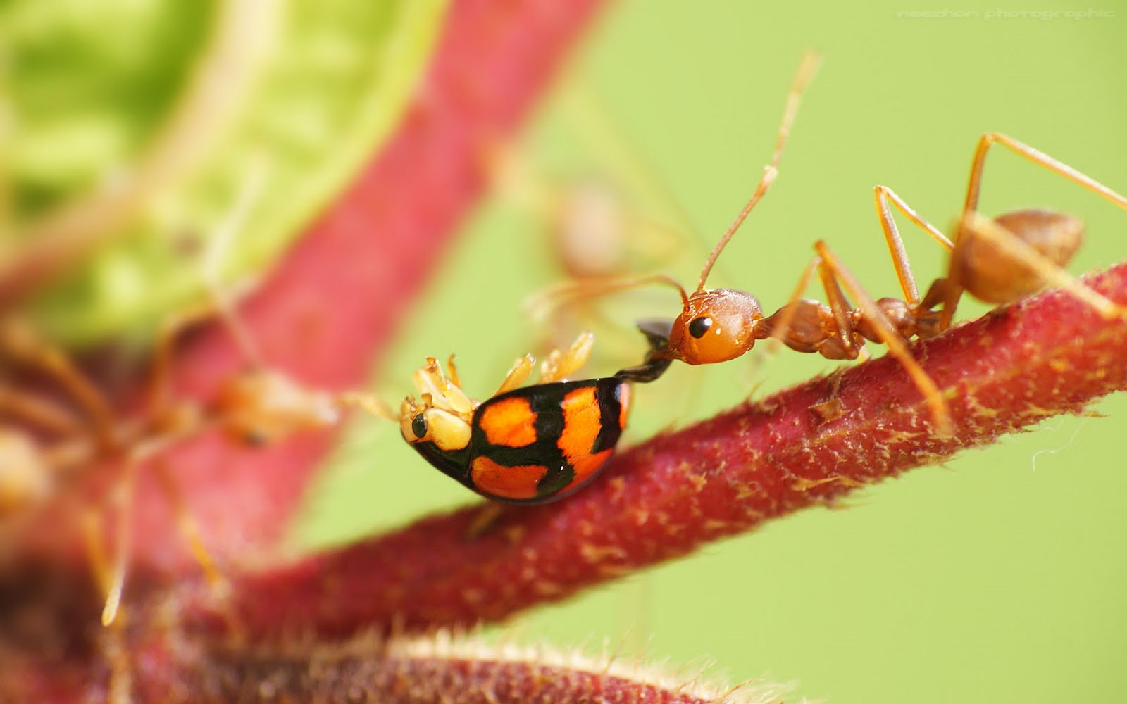
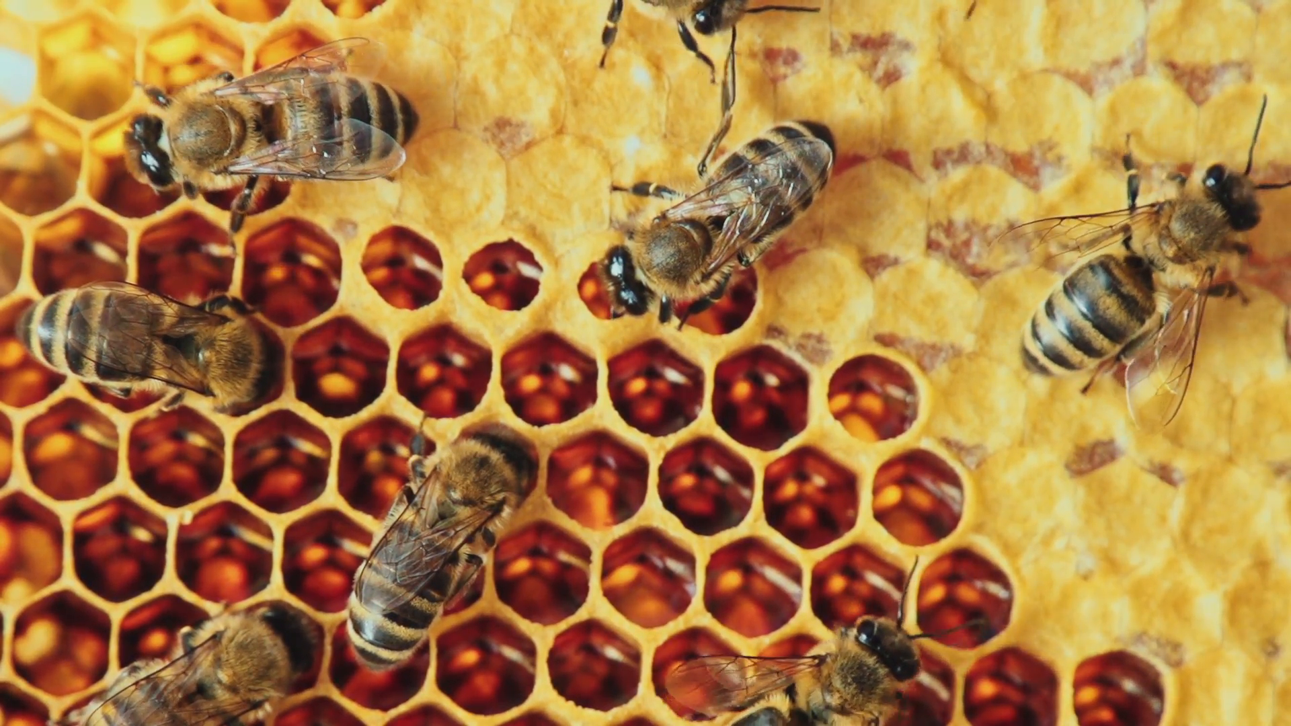
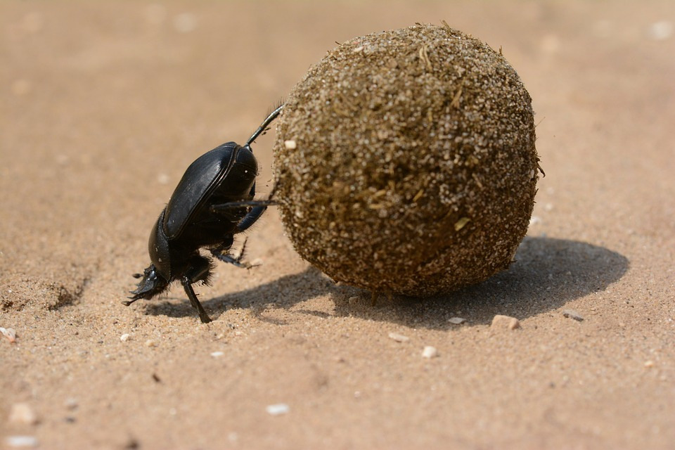
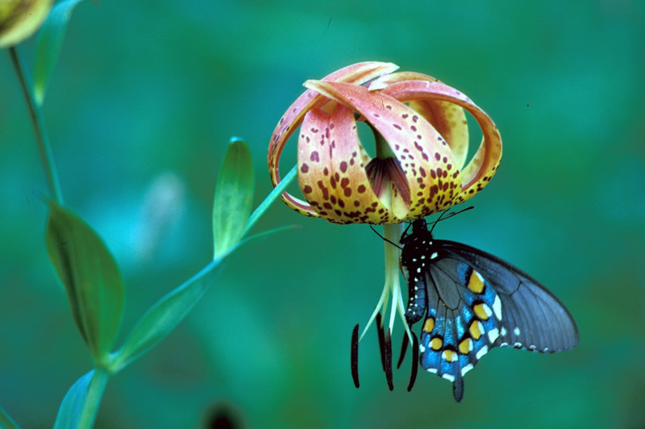
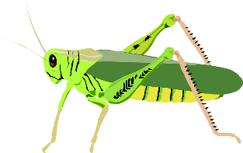  Grasshopper | 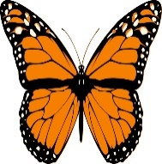  Butterfly
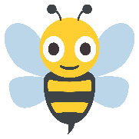  Bee | 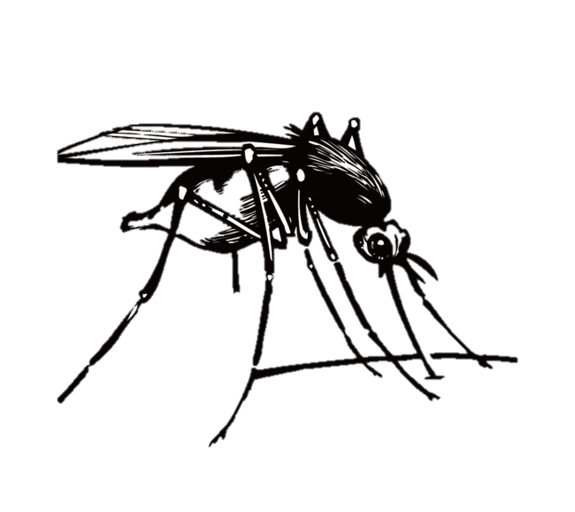  Mosquito
Grasshopper | Butterfly
Bee | Mosquito
Grasshopper | Butterfly
Bee | Mosquito

