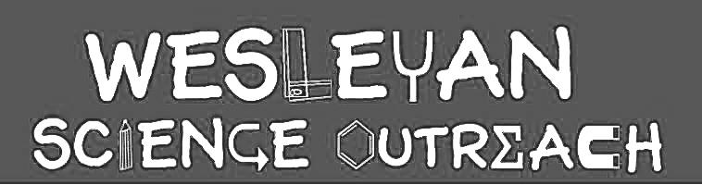

Kayla Jaikaran
1/29/19
Fats

This lesson will teach kids about the different kinds of fats they can find in the foods they eat. They will learn the differences between healthy and bad fats and how fat, in moderation, is really good for our body’s functioning and development. They will also be able to visualize fat content in milk.

Material List
Key Words

- Unsaturated Fats (Good Fat)
- Saturated Fat (Bad Fat)
- Trans fat (Another Bad Fat)
- Vitamins
- Hormones

- 4 Fat sorting charts
- 4 sets of fatty food cutouts

Activities

1. Intro to Fat!
Duration: 15 mins

Who knows what fat is? The name fat might sound like a bad word or something you shouldn’t eat, but fat is actually an important part of a healthy diet! Can anyone name some foods with fat in it? (Kids will probably name junk foods) List some foods with fat in it, like meat, cheeses, and butters. It is true that some fat in foods are bad for you, but there are plenty of foods with fat that is good for you! Can anyone think of any? Some foods with good fat are nuts, fish, olives, and avocados.

Good fats are known as “Unsaturated Fats” and help our body work!

Bad fats, like fat in junk food and butter and fried things are “Saturated Fats” and also help our body stay healthy, but only if we eat them in moderation. If we eat too much bad fat, our body won’t be very healthy and we won’t have much energy.

Another kind of bad fat is called “Trans fat” and that is the kind of fat that’s found in foods that don’t come from nature. That is the kind of fat that is in potato chips and cookies and other snacks from the grocery store. It’s like a “fake fat”. Trans fat also is only good for you if you eat a little bit!

Why do we need fat?
Fat helps our bodies grow like it should. Fats give the body energy and help our bodies take in vitamins. Fat also lets our bodies form hormones that help us grow. On top of that, fat keeps us warm!

STRESS THIS: Fat is not the enemy! Fat is good for you if you eat the right amount and the right kind (Good fats; Unsaturated). If you are getting your fat from things like lean meat, fish, and nuts, you are on the right track!

2. Good Fat vs. Bad Fat Sorting Chart
Duration: 15 mins

Break kids up into 4 groups. Each group gets a fat sorting charts with two columns “Bad” and “Good”. Kids will list and write down some examples of good vs. bad fats with expo markers. Once each group is done, the class will reconvene and each group will be asked to share their ideas.

3. Let’s See Fat in Milk!
Duration: 10 mins

Volunteers will demonstrate how we can see fat in milk. One 250ml beaker will be filled up with 100 ml of skim milk and another with 100ml of regular milk. Volunteer will drop 2 drops of food coloring in each beaker and stir. Skim milk beaker will develop more color showing that there is less fat and regular milk beaker will show less color, showing more fat.
This is because food coloring likes to mix with water! When there is less fat in milk, there is more water in it that the food coloring can mix with! When there is more fat in milk, the food coloring can’t mix as well because there is less water in it!

4. Draw your favorite healthy fat!
Duration: 5 mins

Pass out paper and drawing/coloring utensils. Kids will draw their favorite food to eat containing a good fat.

Conclusion

Fat is a part of food that helps our bodies work and stay healthy, if we eat the right amount. There are good fats and bad fats. Good fats (Unsaturated fats) are found in food like fish and nuts. Bad fats (Saturated and Trans), the kind that can hurt our bodies if we eat too much of it, are found in meats, fried foods, chips, cookies, and other junk foods!

Instructor Comments

Be very careful that the kids only use expo markers on the charts. Possibly let an older child volunteer stir the food coloring into the milk. Stress that fat isn’t always bad for you!

