[Discovering the Digestive System]

Students will be able to learn about the key body parts that play a key role in our digestive system. Via interactive and instructive activities, students will grasp the anatomical and functional processes of the digestive system.

Material List
Key Words

- Esophagus
- Stomach
- Small Intestine
- Large Intestine
- Anus
- Digestive System

- 3 colored unlabeled digestive system posters
- 3 colored labeled digestive system posters
- Unlabeled colored digestive system black and white worksheets
- Digestive system index cards (2 stacks)
- Markers and crayons
- 3 laminated pictures of good gut bacteria
- 5 unlaminated labeled posters of the 5 special gadgets (parts) of the digestive system
- 30 laminated food plates #type 1
- 30 laminated food plates #type 2
- Green Checkmarks
- Red Xs
- Unlabeled black and white digestive system worksheets

Activities

1. Introduction to the Digestive System
Duration: [10 minutes]

Inform the students that they will be learning about the digestive system. Ask if anyone can tell you what they think is a “digestive system”. Inform them to consider the human body as a factory that consists of different special machines that operate the entire body. *Hold up the unlabeled colored picture of the upper body* The digestive system is one of those special machines that operates food ingestion. Everything that we put in our mouth and swallow, our digestive system machine turns on and transforms those foods into nutrients, proteins and other necessary chemicals that our body needs in order to operate. Ask them if they can tell you the names of the specific body parts that are within the digestive system machine. *Hold up the picture with the labeled different digestive system organs* Inform them to consider the different body parts in the digestive system as special gadget. Go through the labeled diagram starting with the Esophagus.
Esophagus = transports food down the body
Stomach= food is broken down into liquid substance
Small Intestine= absorbs the nutrients from the food liquid
Large Intestine= water is absorbed from the food liquid and liquid turned into solid substance
Anus= where waste comes out
The waste form of our food is then excreted from our body through the anus. State that this is when we know that have to go number 2.

Ask the kids how long they think it takes for them to digest their food. State that it takes about 6-8 hours for you to digest your food!
IF THE KIDS ASK WHAT IS ABOVE THE STOMACH, SEE INTSTRUCTOR’S COMMENTS

State that sometimes bacteria is seen as a negative thing. But there are good bacteria that is present in our bodies. These good bacteria are also present in our digestive system! State a specific type of good bacteria is called gut flora and gut flora is located in the both the large and small intestines! Show the laminated photos of what the different types of good gut flora or gut bacteria looks like. The jobs of most good bacteria like gut flora are to:
- monitor the growth of bad bacteria that may be present in your body
- break down chemicals in food that are hard to digest like sugars and starches (bread, pasta, etc).
- makes vitamin B12 which is crucial for the smooth operation of the brain and spinal cord (Central Nervous System). Vitamin B12 also helps your body made red blood cells and you need these red blood cells to breathe.
- makes vitamin K which helps your bones to be healthy and helps the healing process if you ever run and get a boo-boo.
State that sometimes medicine, specifically a medicine called ‘Antibiotics’ help heal your body but sometimes is tricky because antibiotics kills all the bacteria in the body, including the good ones!

2. Digestive Song Jingle
Duration: [10 minutes]

Students will learn the digestive tract jingle to help them easily get acquainted with the digestive tract. The jingle is in “Wheels On The Bus” tone. The lyrics to the jingle are:
The food goes down the esophagus, esophagus esophagus

BREAK DOWN AFTER EACH VERSE
The food goes down the esophagus into the stomach.
The food then goes through the small intestines, small intestines, small intestines,
The food goes through the small intestines, into the large intestines.
The food goes through the a-anus, a-anus, a-anus
The food goes through the a-anus, into the toilet.

3. Fill In Digestive Tract Diagram
Duration: [10 minutes]

Pass out the blank digestive diagram without the body parts and have students fill them in. Before helping them out, advise them to use the jingle to help them get through the worksheet.

4. Which Special Gadget Is It?
Duration: [20 minutes]

This is a fun activity game with the purpose to get the students acquainted with the function of the different special gadgets.

PART 1: Using the index cards, review the special gadgets and their functions with the kids. Then, using the same index cards, with the function on one side and the name of the special gadget on the other side, have one volunteer or the leader read the function side (WITHOUT REVEALING THE OTHER SIDE WITH THE ANSWER). Allow the students to take a guess at which special gadget is responsible for the function. If kids are getting stuck, go through the jingle with them to get the answer. Repeat these steps for all of the index cards with the special gadgets.

PART 2: (YOU WILL USE THE INDEX CARDS ON THIS ACTIVITY TOO) Using the 5 unlaminated labeled posters of the 5 special gadgets (parts) of the digestive system,
tape a special gadget to each corner of the room using the regular sized labeled special gadget papers in the box and instruct students that when the volunteer or the leaders read off the function, they have to SPEED WALK to the correct special gadget corner.

5. Which Foods Help or Harm the Digestive System?
Duration: [10 minutes]

Teach the students that there are foods that we can eat to help out digestive system and that there are foods that harm our digestive system. Ask the kids which foods they think can help the digestive system.
State that some foods that help the digestive system are:
- Apples
- Salmon
- Greens (Spinach, Kale)
- Avocado
- Kiwi
State that some foods that harm the digestive system are:
- Fried Foods (Onion Rings, French Fries, Fried Chicken)
- Spicy Foods (Hot Cheetos)
- Peppermints
- Chocolates
- Coffee
Hand each kid a laminated food plate and using dry eraser markers, have them place a red X on top of the foods that are bad for the digestive system and place a green checkmark on top of the foods that are good for the digestive system. After the kids are done with the meal plate, give the second different version of a food plate and have them do the same.

Color Your Own Digestive System
Duration: [20 minutes]

Pass out the black and white version of the human digestive system and have the students color in the special gadgets of the digestive system.

Trivia
If conclude early, play trivia with them using the trivia card deck in the box.

Conclusion
Students will leave this lesson plan with an engraved knowledge of what the digestive system is and how it works. Via the catchy jingle and activities, students will be expert to how food get broken down in their body and leaves the body.

INSTRUCTOR’S COMMENTS
I wanted to avoid talking about the liver as it has many functions related to digestive system. Many of those functions are far too complex for the kids to grasp. But if kids ask about the liver, simply state that the liver breaks up the fats from the food we digest.
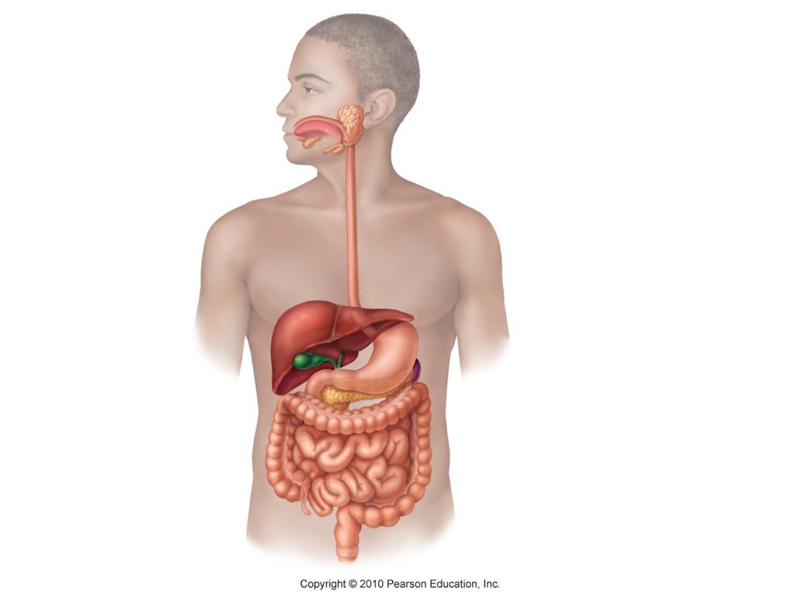

Anus
Small
Intenstine
Large Intestine
Stomach

Esophagus

