Emily Aoki
3/25/2019

Exploring Polarity

This lesson introduces the idea of chemical polarity to kids through demonstrations with different liquids (water, oil, soap). They will learn about positive and negative charges in molecules, and how this keeps the liquids together or allows them to mix with other kinds of liquids.
Key Words

- Polar
- Nonpolar
- Positive and negative “poles” (ends)

Material List

- Stick magnets
- Four 250 mL beakers
- Model water molecule
- Vegetable Oil
- Water
- Dish soap (more)
- Spoon(s)
- Worksheets
- Markers/crayons
- Paper plus/minus signs
- Painter’s tape
- Paper towels

Activities

1. Intro to Polarity and brief magnet demo
Duration: 10 min.

Have you ever wondered why when you rinse a dirty dish with just water, the oil and grease won’t come off, but when you use soap it does?
This happens because of chemical property called polarity. Water molecules, for example, are able to stick together as a liquid because the individual molecules are polar. This means that one end of each molecule has a slightly positive charge, while the other end is slightly negative, and like two magnets, two molecules can line up so the positive and negative ends are attracted to each other. (Demonstrate this to the kids using the model water molecule). This happens with all the little molecules of water in a cup and it keeps them from completely separating, even when you spill it.
(Here you can use the stick magnets to demonstrate how the positive and negative ends align, asking the kids to imagine that each magnet is a molecule of water). Pass around the magnets after you’re finished.

2. Diagram worksheet
Duration: 15 mins

Hand out the worksheets to the kids and point out the polar ends on the diagram of the water molecule. Help them to define polar: a polar molecule has two poles, like the north & south pole of the earth, but a positive “pole” and negative “pole,” like a magnet. Have them write down this definition, then ask them what they think the word nonpolar means based on this definition. Ask them to write down the definition of a nonpolar molecule, which is neutral and does not have a positive & negative ends. Another way to think of this is, if polar is pluses and minuses, nonpolar is zero.
Then point out the bottom two diagrams, and show how the positive and negative ends of water are attracted, and how the hydrophilic head of the soap molecules touches the water, and the hydrophobic tail touches the oil particle. Let them ask any questions they have and then move on to the demos.
Another helpful way to explain this is, if you are pretending to be a soap molecule, and the person on your left is “water” and the person on your right is “oil,” your left hand is the hydrophilic side and you can grab onto water with one hand (like hold their hand to represent the chemical bond), and grab onto “oil” with your right hand, or your hydrophilic side.

3. Polarity Chain Tag
Duration: 15 min.

Alternate as you distribute the polarity charge signs (i.e. plus, minus, plus, etc.) so they are mixed up. Give one paper sign to each kid for them – you can either tape it to their shirts or have them put them in their nametag holders. Half should be plus and half should be minus. Now explain to them this version of chain tag, where you have one person who is the tagger and another who is being chased. If the kid being chased has a plus and links up with a kid who has a minus, they are safe from being tagged. However, the third person who was originally linking arms with the minus must now run and find another partner before they are tagged, or they become the tagger. Only plus’s and minus’s can link up (no plus/plus or minus/minus, as we learned with polarity).
If no one gets tagged for a while, switch so that the other sign has a chance to run (otherwise it could just be only one running around forever).

4. Oil, water, & soap polarity demo
Duration: 15 min.

Split up into 4 groups and do the demo with the small groups interactively. Gather all the kids around the 250 mL beaker, filled halfway with water. Color the water with food coloring. Remind them that water molecules are polar (like magnets), and tell them that oil particles are nonpolar. Ask them what they think will happen when you pour oil into the beaker based on what we’ve learned so far.
Pour ~50 mL of oil into the beaker and let it settle so the divide between the oil and water is distinct. Explain that even if you stir it, the water and oil won’t mix, because the water is polar and acts like a magnet, while the oil is nonpolar and isn’t attracted to the water, like if you put the magnet against the wood/plastic table.
After letting them ask any questions they have about the oil/water solution, ask them what they think will happen when you pour soap into the beaker, based on what we’ve learned. Remind them of the diagrams on their worksheets and let them use those to help answer if necessary. After making predictions, pour ~50 mL (or like a couple of big squirts) of soap into the beaker and stir the solution. Show them how it all mixes together and there’s no line of separation, and remind them that it is because of the special property that soap molecules have of being “half-polar” and “half-nonpolar.”

Conclusion

Polarity is an important chemical property that plays a role in nearly everything around us. Polar molecules have a positive pole (end) and a negative pole, and this lets them interact with each other and other types of molecules through magnetic attraction. Water is polar but oil is nonpolar, so they won’t mix because they aren’t magnetically attracted to each other, but when you add soap, which is half polar and half nonpolar, it connects the two and allows them to mix together. Next time you wash the dishes, think back to how these little molecules that you can’t see are behind everything that liquids can do.

Instructor Comments
Don’t worry about whether all the kids totally “get it,” just do your best to explain it minimally, clearly and consistently. If you feel anything is repetitive, skip over it or rephrase it in a way that makes sense to you. Try to interest them as much as possible by hyping it up as super cool, and let them keep the worksheets when they leave if they want so they can look at it & think about it later.
Useful diagrams for volunteers:
(feel free to show as part of the lesson as well)

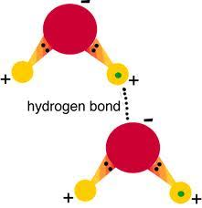
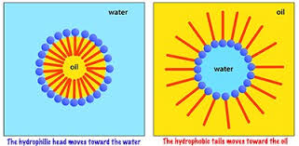

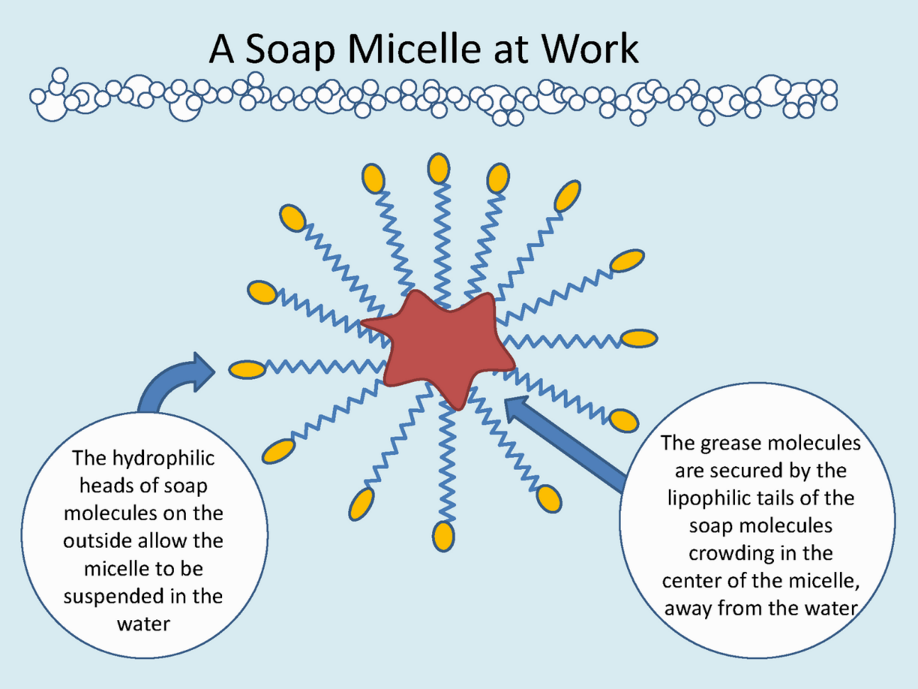

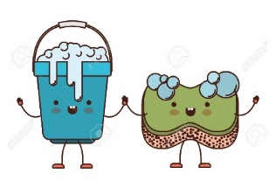
Exploring Polarity
Important Definitions:
- Polar = ________________________________________________________________________________
  - Example: water
- Nonpolar = ___________________________________________________________________________
  - Example: oil

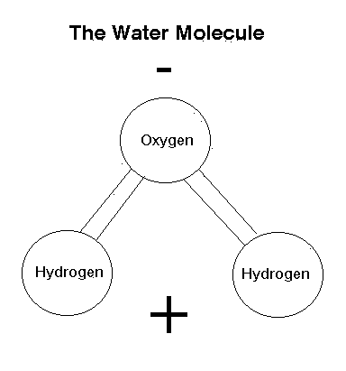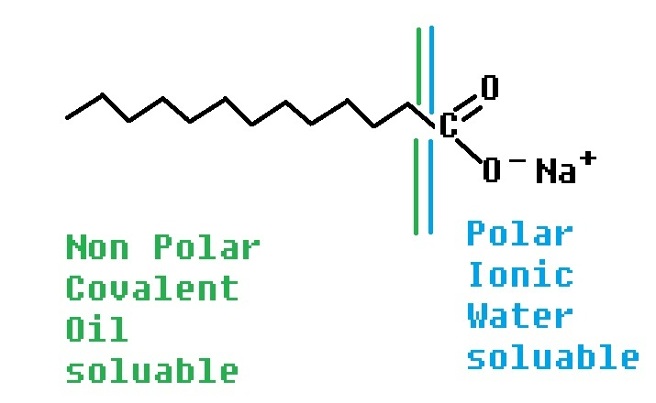
The Soap Molecule

How soap works:
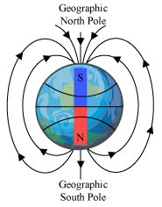
(zero)
+/-
+/-
+/-
+/-
+/-

EXTRA CREDIT: You may wonder…what are those lines around the picture of Earth? Magnetic fields!
Signs for playing tag (to be cut out individually)

