Wesleyan Science Outreach Lesson Plan

Bridge Building

Introduction
In this lesson we will focus on bridges: how they work, and why it’s important that they work properly. We will build and test the strength of truss bridges. Truss bridges are built of only straight beams - that means that they do not contain arches. Truss bridges almost always contain triangles because the triangle is the strongest of all the geometric shapes (take-home message). Build a square out of toothpicks and gumdrops, then show the kids how flimsy it is. Now build a triangle and show them how strong it is (if anyone asks, it is because triangles have fewer points of rotation).

Materials
Toothpicks
Gum drops
Mike and Ike candy
Practice paper bridge templates
Testing cardboard bridge template
Pictures of truss bridges
Pencil
Plastic cup with strings attached
Weights

Bridge Examples:

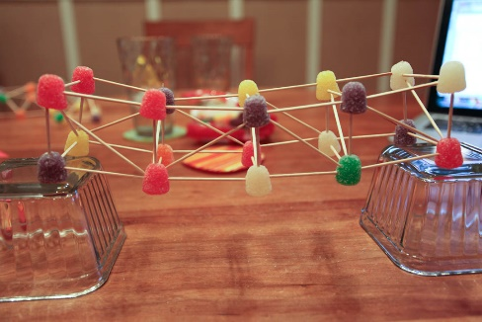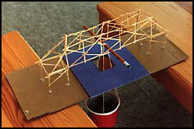
Neither of these are exactly what we will be building, but they give a good idea of what we are going for.

Demonstration
Show the kids the demo bridge (included in the bin). It is built to be flimsy, so you can twist and bend it to show the kids. Ask them if they think this would safely carry students across a lake. Explain that if this bridge were built in real life, it would be much bigger but would behave in the same way. Good thing that the engineers didn’t just go ahead and build the bridge without making a littler version and testing it first!

Activity
Introduction
- Tell the kids: There’s a lake in the middle of Wesleyan! Every day, the students have to walk all the way around the lake just to get to class. Is there a way to make the students’ walk shorter?
- If it hasn’t already been suggested, tell them that a bridge would be a good idea.
- The engineers at Wesleyan want your help for bridge ideas! It would be too expensive and time-consuming to have everyone build a real bridge, but they can all make models. A model can give us a really good idea of how something like a bridge, or an airplane, or even something more scientific, would work in real life, without actually building something so big.
- We don’t want to make the models too big, so we will scale them down so that they cross a lake that is 6 inches wide. The bridge’s beams will be shown by the toothpicks. When we test the bridges, the pennies that we use will stand for people. The engineers are looking for super strong bridges that can hold at least 5 people, or in this case, 5 pennies.
- Ask them if they remember what type of geometric shape is strongest (the triangle). It would be a good idea to use triangles in their designs to make the bridge as strong as possible.
Procedure
- Pass out one paper template, 30 toothpicks, 8 gumdrops for the base of the bridge, and ~20 more gumdrops (or Mike and Ike candies) to each kid to begin.
- Tell the kids their goal is to build the strongest bridge that passes over the ‘river.’ The bridge should be about six inches long.
- When all the kids are done, begin testing all the bridges one by one by placing each bridge on the cardboard template. Set it up in between two tables or desks, attach the cup/string device, and add pennies to it. For reference about testing, see the second bridge example photo (above). Feel free to adjust the testing process as you see fit, based on the number of kids and the quality of their bridges.
- If you have time, allow them to expand on their bridges to make them better and bigger!
Post-Activity Discussion
- It’s important to make models when designing something new.
  - Question: How can models help us?
  - Answers: See how strong something is, see how something will behave in the real world, know what to expect when we build the real thing
- It’s also important to take measurements and evaluate new projects when you create them.
  - It’s not enough to just draw something and hope that it works
  - We have to make sure that all the parts will work together to create a successful final product. Doesn’t only apply to bridges!

CLEANUP NOTE: try to salvage any toothpicks and candies that you can!

EXAMPLES OF TRUSS BRIDGES
